

Table of Contents

Main Website | 1
Member Log In | 2
Password Change | 3
Email Update Page | 4
MEMBERS | 5
Member Profile Page | 5
Overtime Request | 6
Overtime Work History | 9
Guaranteed Holiday Report | 10
Guaranteed Holiday Application | 11
CHIEFS | 12
Chief Daily Worksheet | 12
District Debit Day Assignment | 14
District Scheduled Vacation | 15
District Non-Vacation Leave | 16
District Unscheduled Leave | 17
District Guaranteed Holiday | 18
District Benefits Approval List | 19
District Higher Classification | 21
District EMS Apparatus Staffing | 23
District Adjusted Personnel on Duty | 25
District Fill In | 27
District Daily Remarks | 29
Hold Over | 31
Scheduling Vacation Time | 32
Scheduling Absences | 34
Scheduling Unscheduled Absences | 35
District Work Sheet – Day Of | 36
District Work Sheet – Projection | 38
Exception Pay | 40
QUADRANT CHIEFS | 46
Quadrant Chief Worksheets | 46
Quadrant Worksheet – Day of | 47
Quadrant Worksheet – Projection | 49
SHIFT COMMANDERS | 51
Shift Commander Worksheets | 51
Shift Commander Work Sheet – Day of | 52
Shift Commander Worksheet – Projection | 54
APPENDIX | 55
SAP Absence Codes | 55

MAIN SCREEN

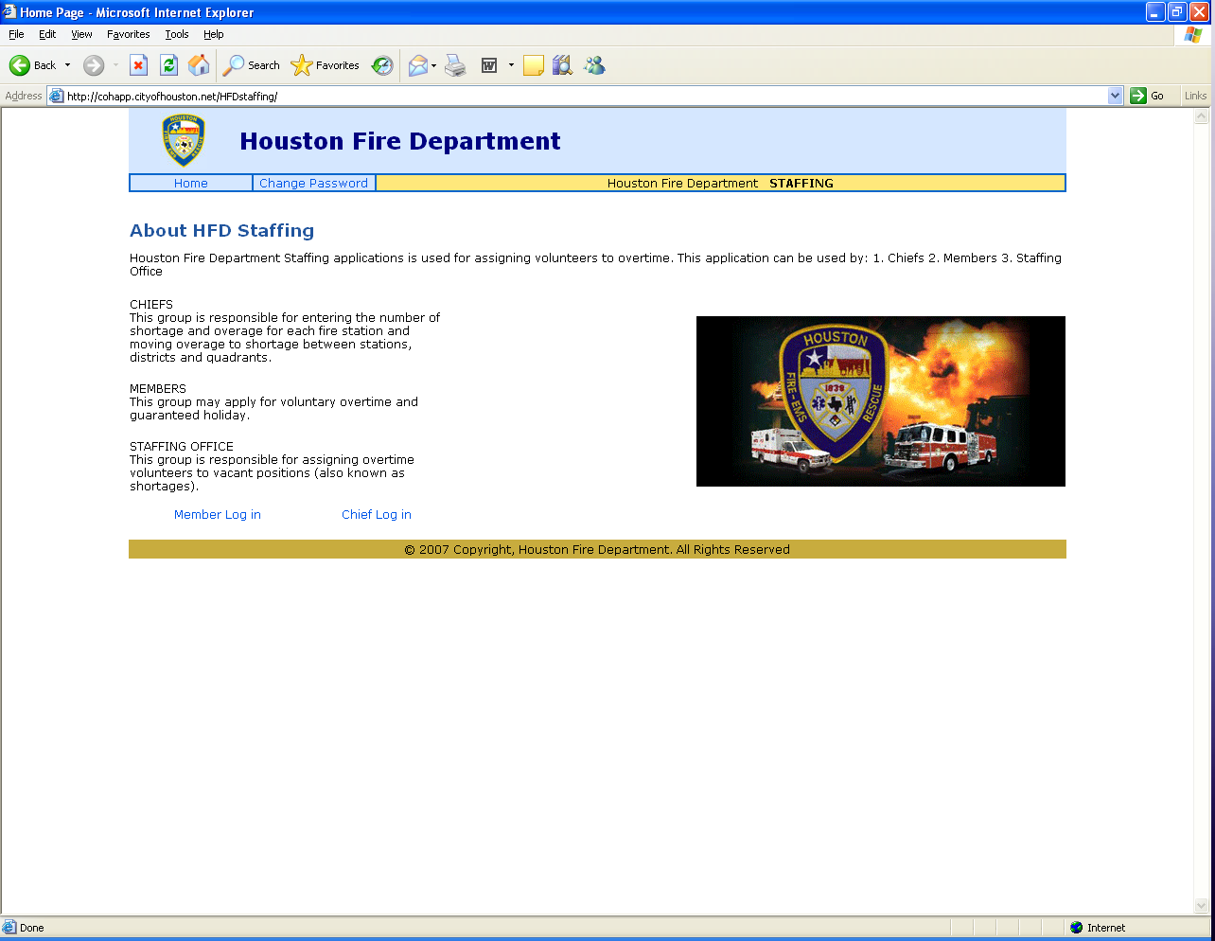

The address for the HFD Staffing website is http://cohapp.cityofhouston.net/HFDstaffing/

From here, the user will select his log-in category. The user may also choose to change his password.

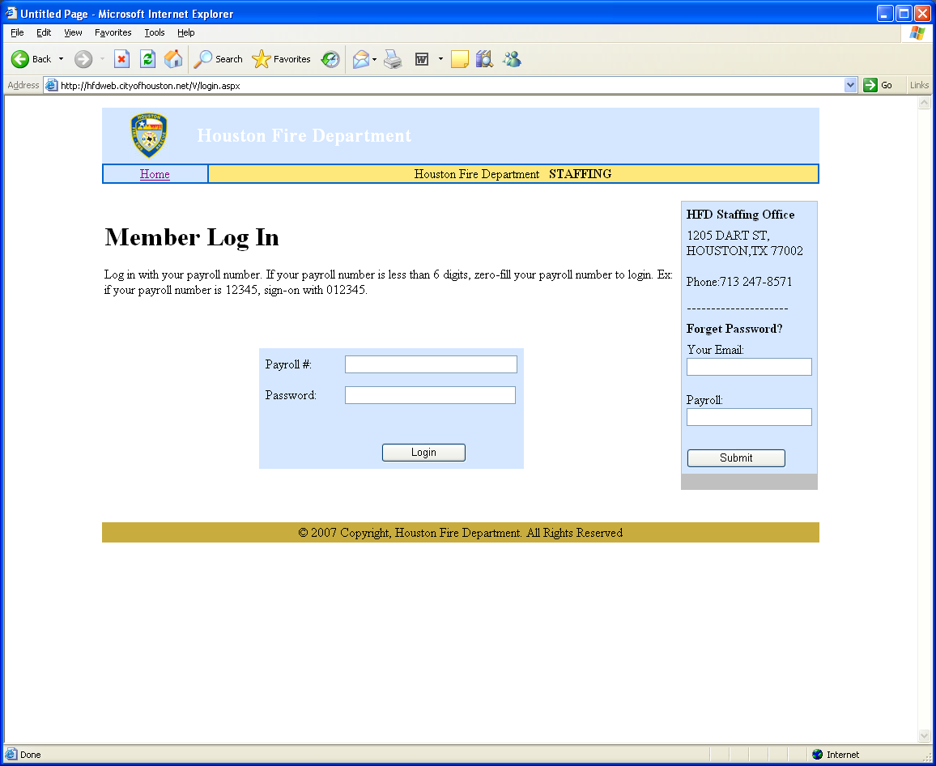

The payroll number requires 6 digits so if the user’s payroll ID is only 3 digits the extra digits can be added to the beginning of the payroll number by using zeros, ex: 000123.

The first time the user logs in, he will use the last four digits of his social security number for the password. He will then be directed to change his password for security purposes.
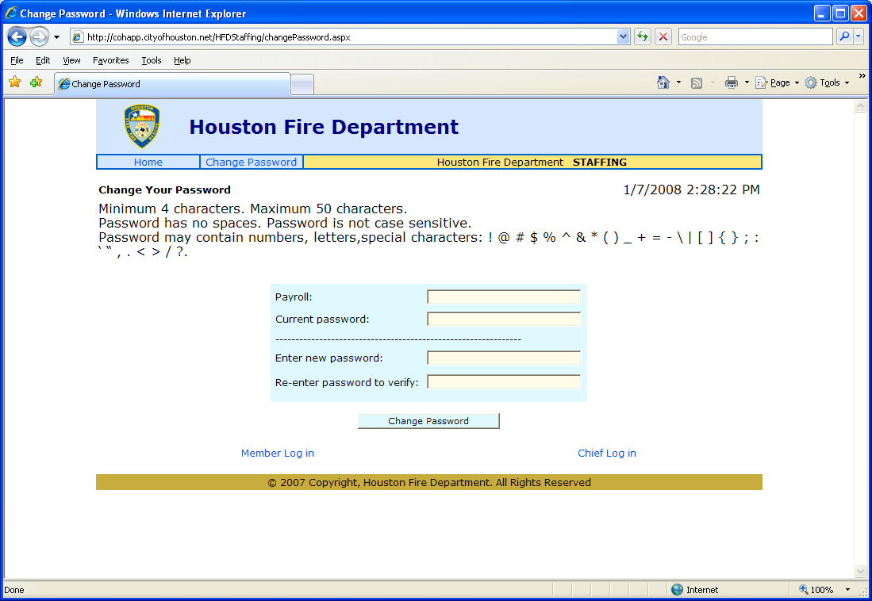

The user cannot use spaces in his password.
Capital letters are treated as small letters.
Numbers and special characters are also acceptable.

When the password change is successful, the user will have to click Member Log in or Chief Log in and log in with the new password.

Should a user forget his password, he may request a new one by entering his e-mail address and his payroll number on the main page website. A new password will be issued to him and he will be informed by e-mail.

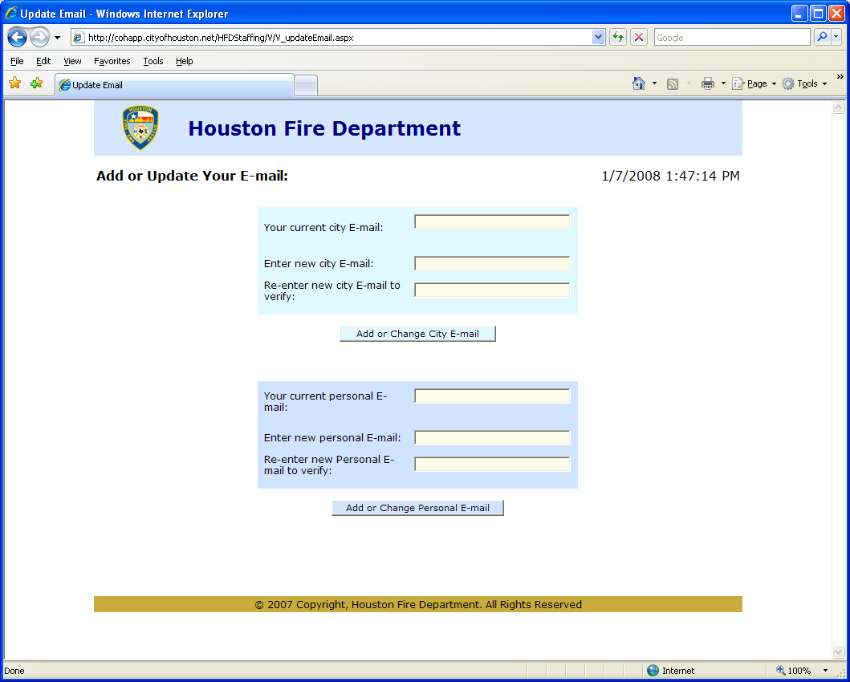
The first time that the user logs in, he will be required to enter an e-mail address.
And then re-enter the e-mail address to verify it.

The user can enter either a City of Houston e-mail address
or a personal e-mail address
or both CoH and personal e-mail.
Updates will be sent to the address(es) on file.

When the e-mail is accepted, options will become available on the menu line at the top of the page.

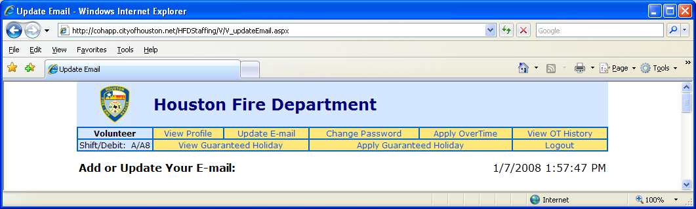

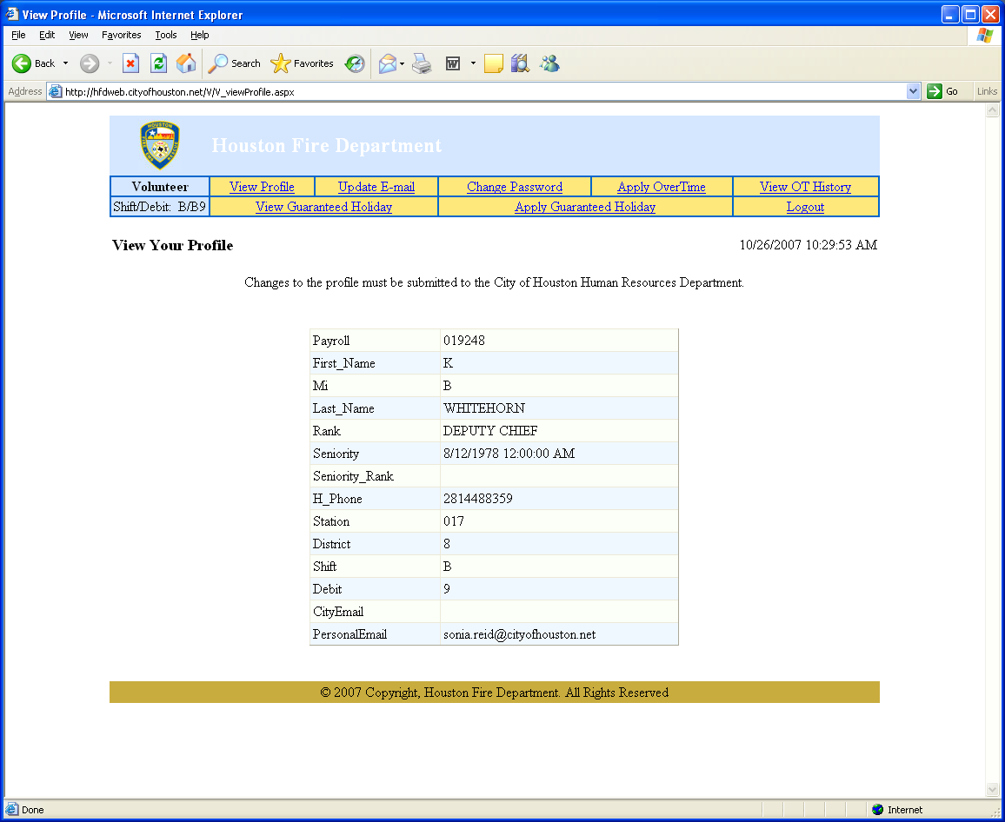

This is the user’s profile page. Most changes to it need to be submitted to the Human Resources Department. The user can update his e-mail address, add a personal e-mail address and change his password.

From this page, the user can navigate to apply or view for overtime or guaranteed holidays.

The Shift/Debit day is indicated in the upper left-hand corner.

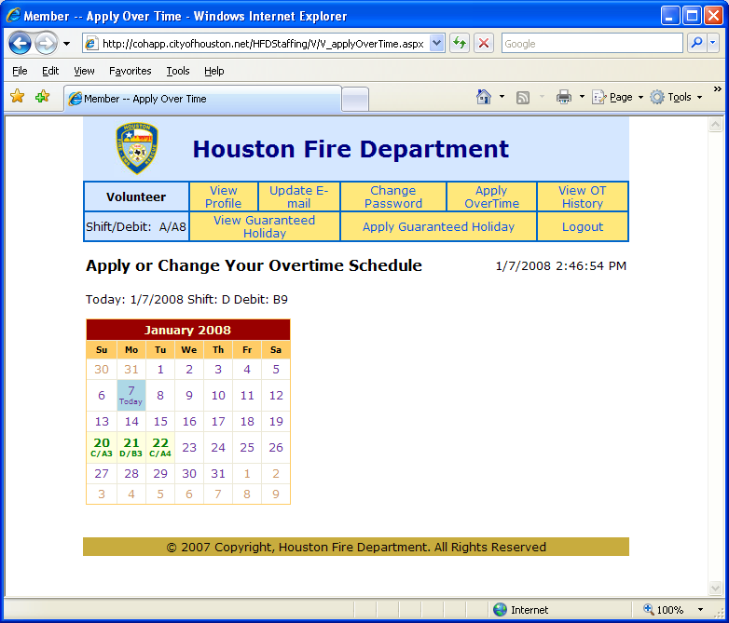

The calendar will show the user which days that he is eligible for overtime.

When the user CLICKS ON A DATE in the calendar, he will be shown three choices.
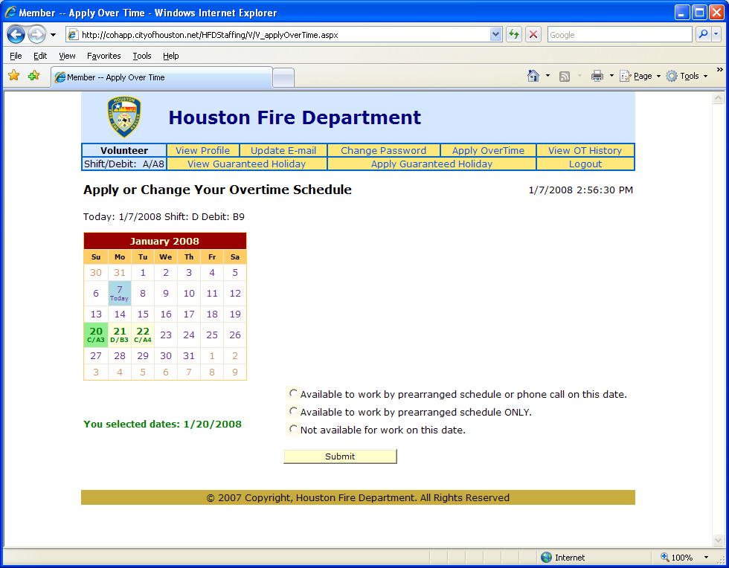

1. He can apply for overtime by prearrangement only on the selected day.

2 He can apply for overtime by prearrangement or phone call on the selected day.

3. He is not available for work on the selected day.

The user selects an option and MUST CLICK SUBMIT for the overtime request to be entered.
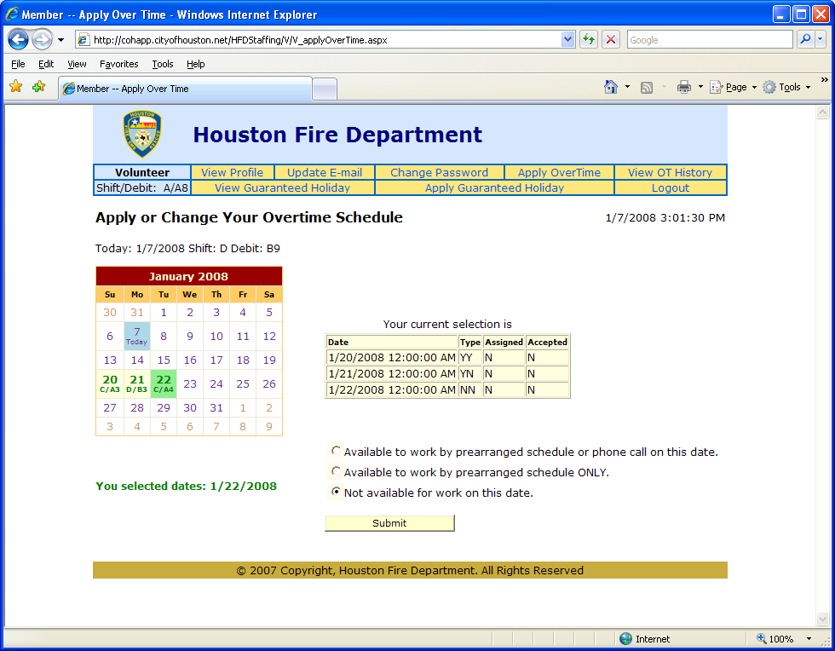

A chart will also display the user’s current selections.
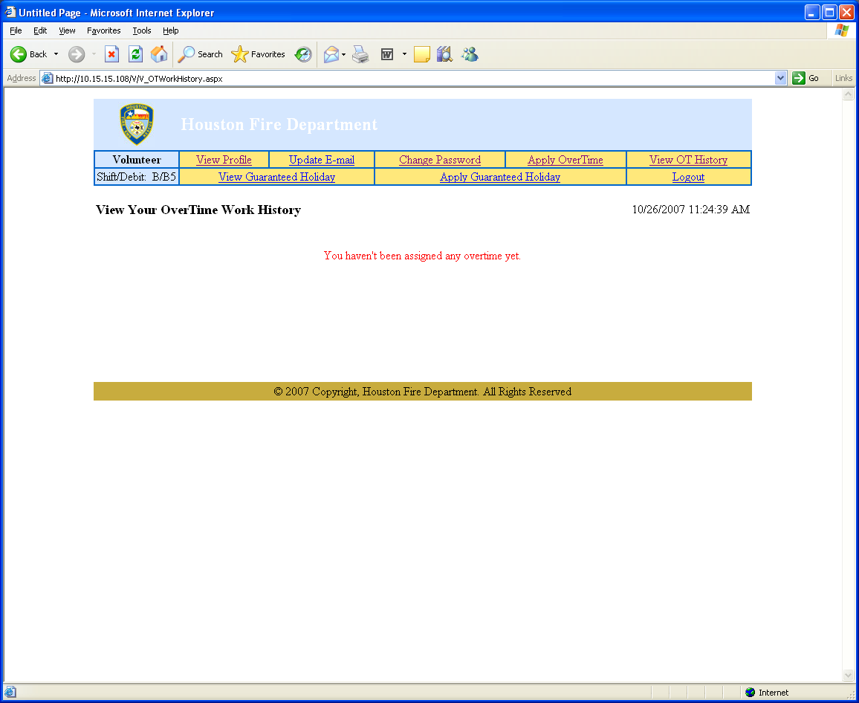

The user can view his assigned overtime on this webpage.

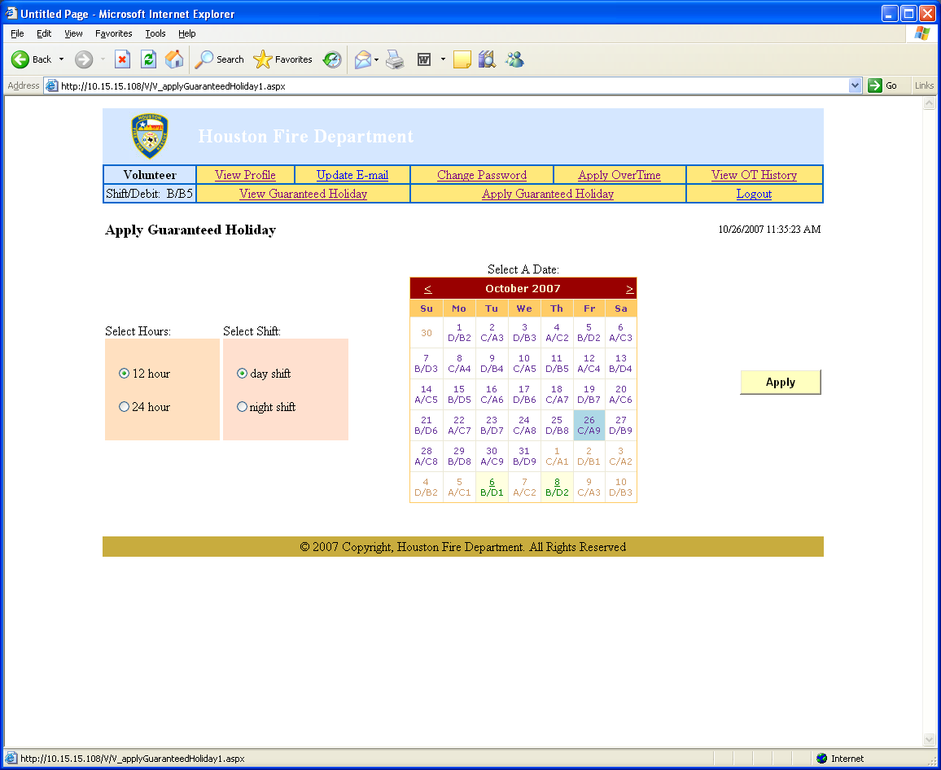

The user may apply for a guaranteed holiday on this webpage.

The calendar will highlight the days that he can use for a guaranteed holiday.

He needs to select a date, then
select day or night shift if he has selected a 12-hour holiday,
or select a 24-hour holiday.

Then he must click APPLY to update the records.
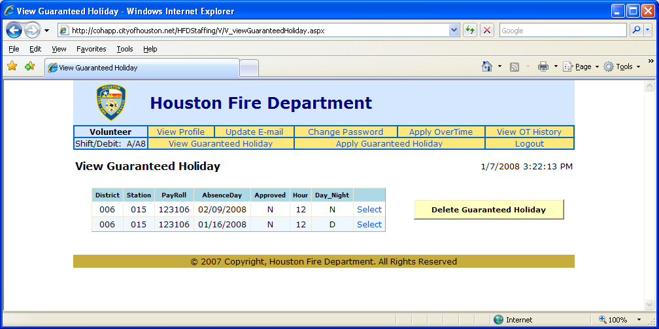

The user can view his guaranteed holidays on this page. He can also delete his request for a guaranteed holiday.

If his Guaranteed Holiday has been assigned, the user will not be able to delete it.

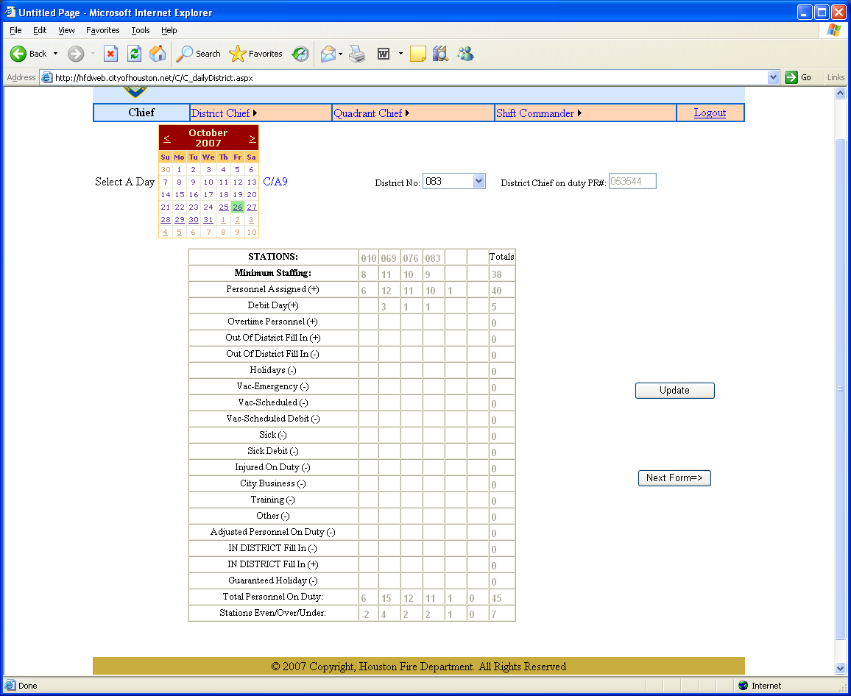

From this webpage, the chiefs can view the staffing at the various stations in the various districts.

The chief can select a day or select a district to view the staffing allocations.

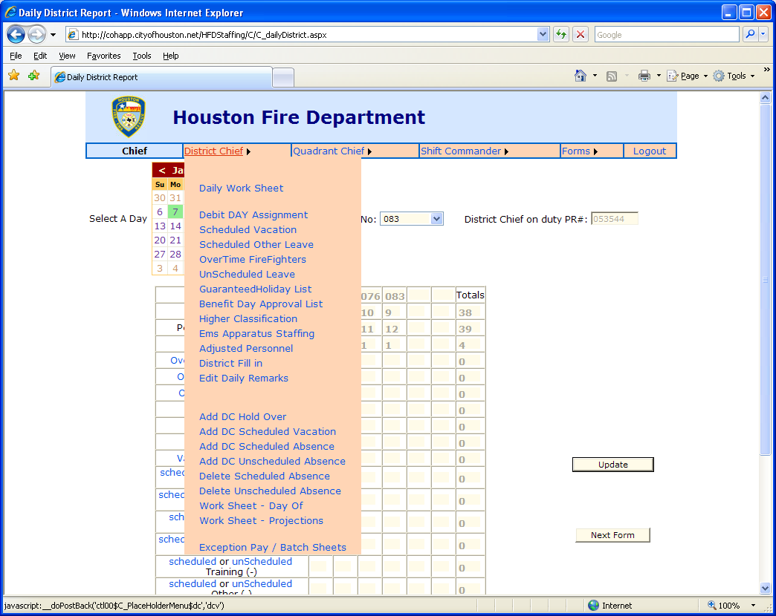
Click To Select Page
By moving the mouse to the District Chief or Quadrant Chief or the Shift Commander boxes,
the Chief can jump to any of the various worksheets.
Or by clicking NEXT, the chief can scroll through the available web pages.
Or by clicking on the items in BLUE type, he will be taken to that worksheet.

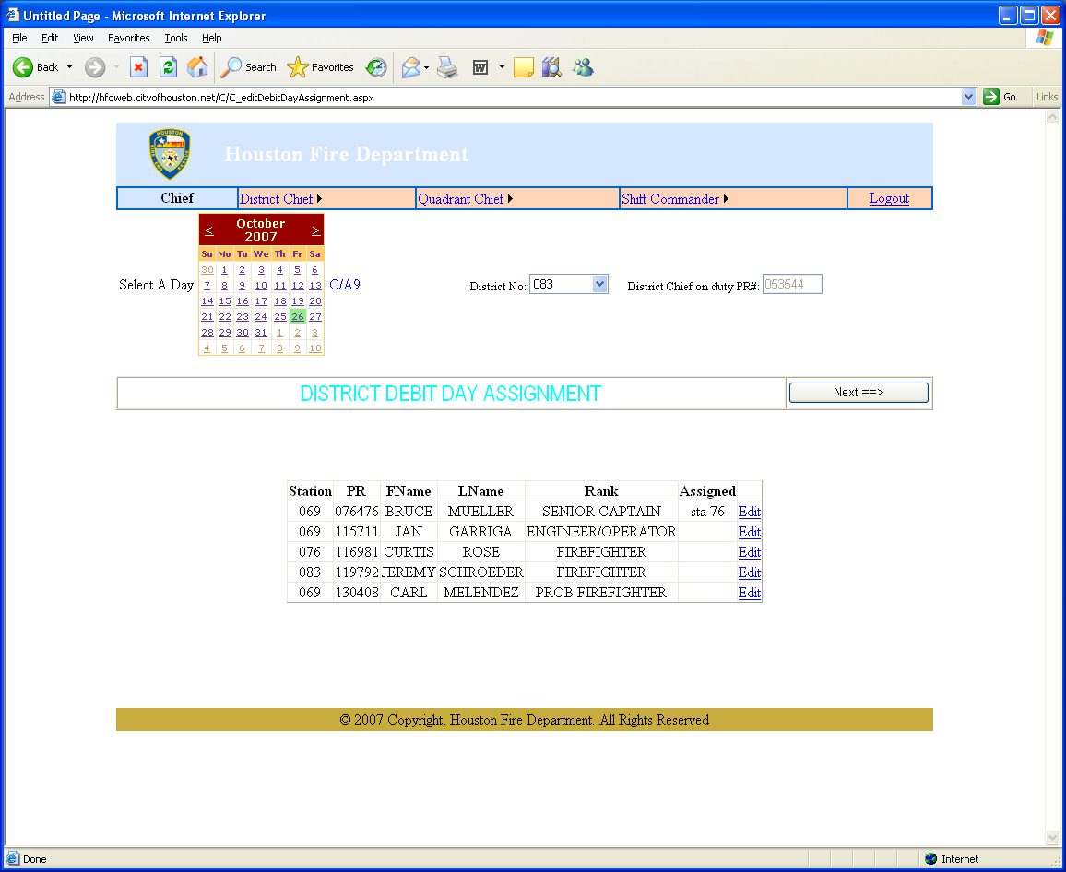

The Chief can view assignments from this page. He can edit Debit Days from here.

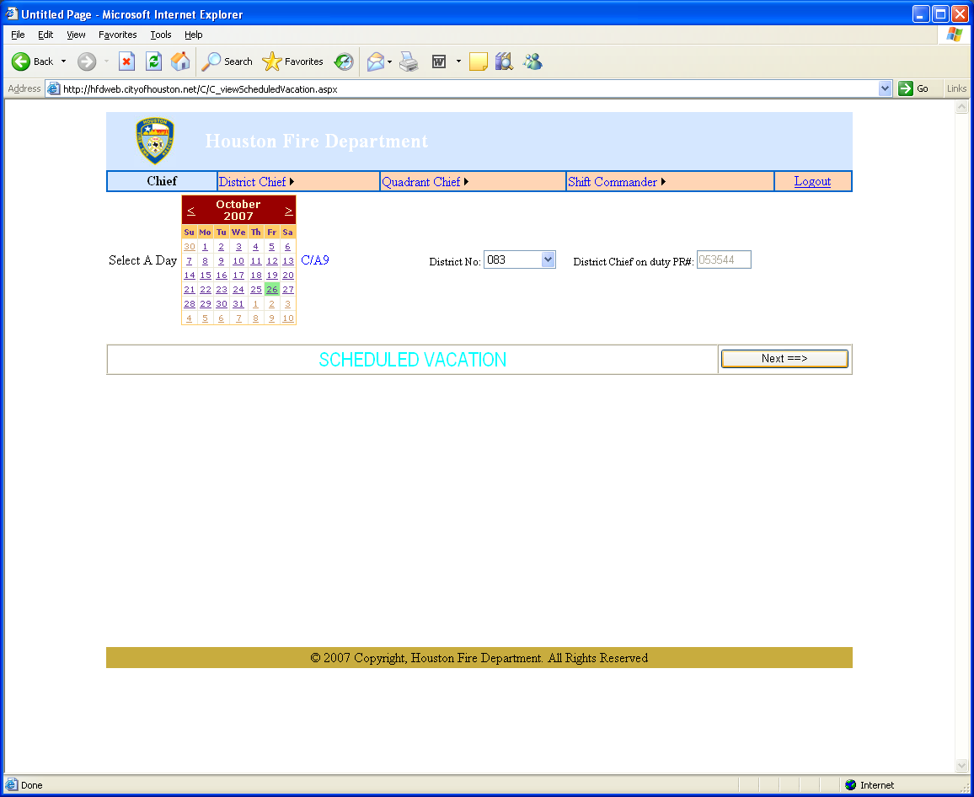

The Chief can view the scheduled vacation days from this website. He can change the date or the district by using the calendar or drop-down box.

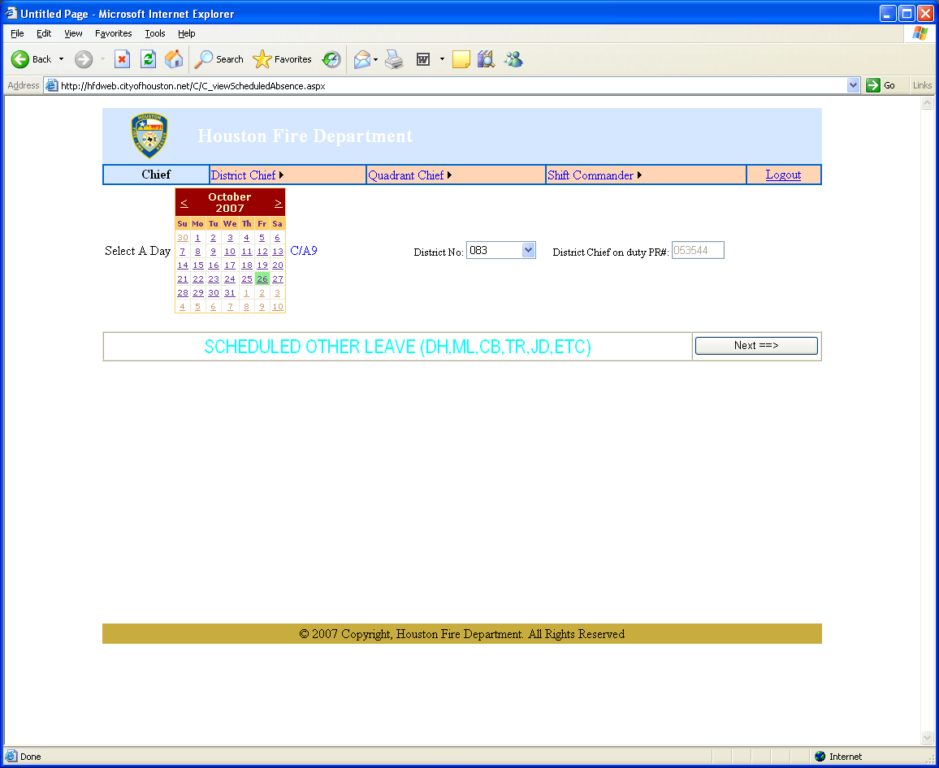

The Chief can view non-vacation absences from this page. He can view different dates and districts.

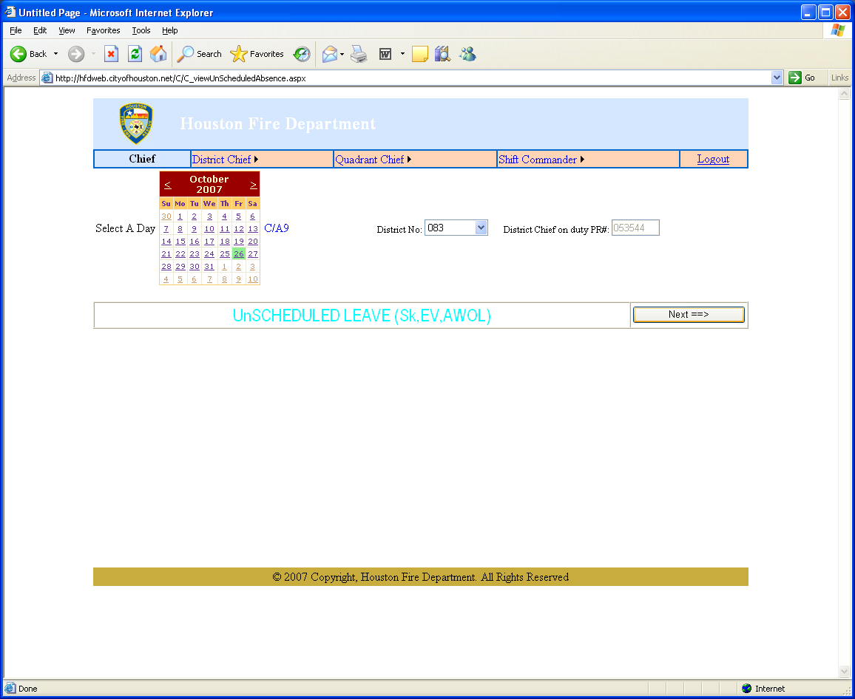

The Chief can view unscheduled leave on this webpage.

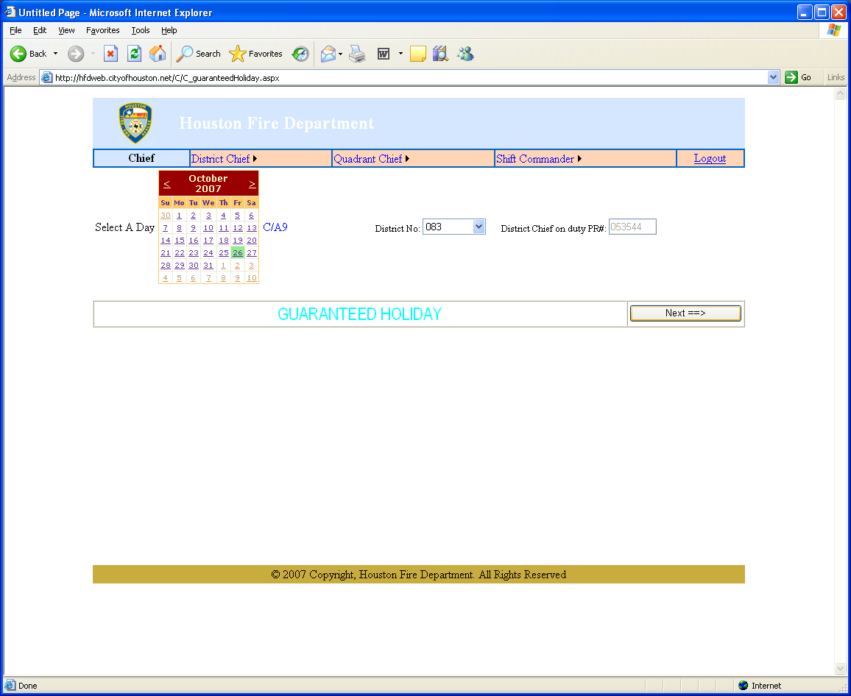

The Chief can view those on Guaranteed holiday.

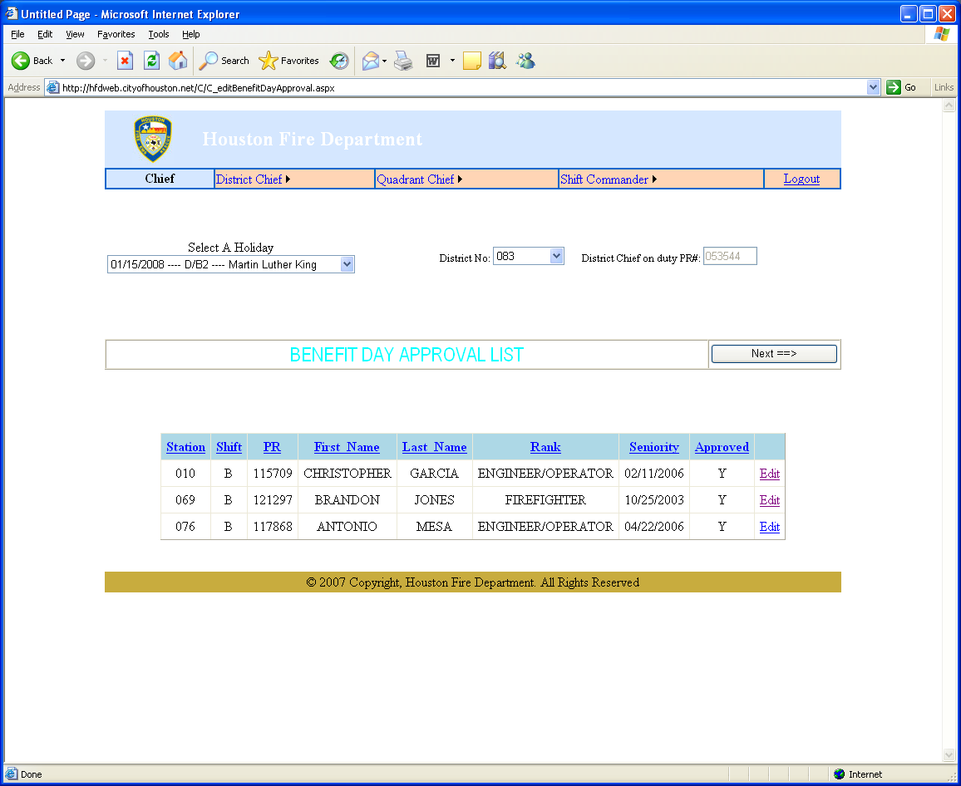

The Chief can view and edit the Benefit Day Approval List.

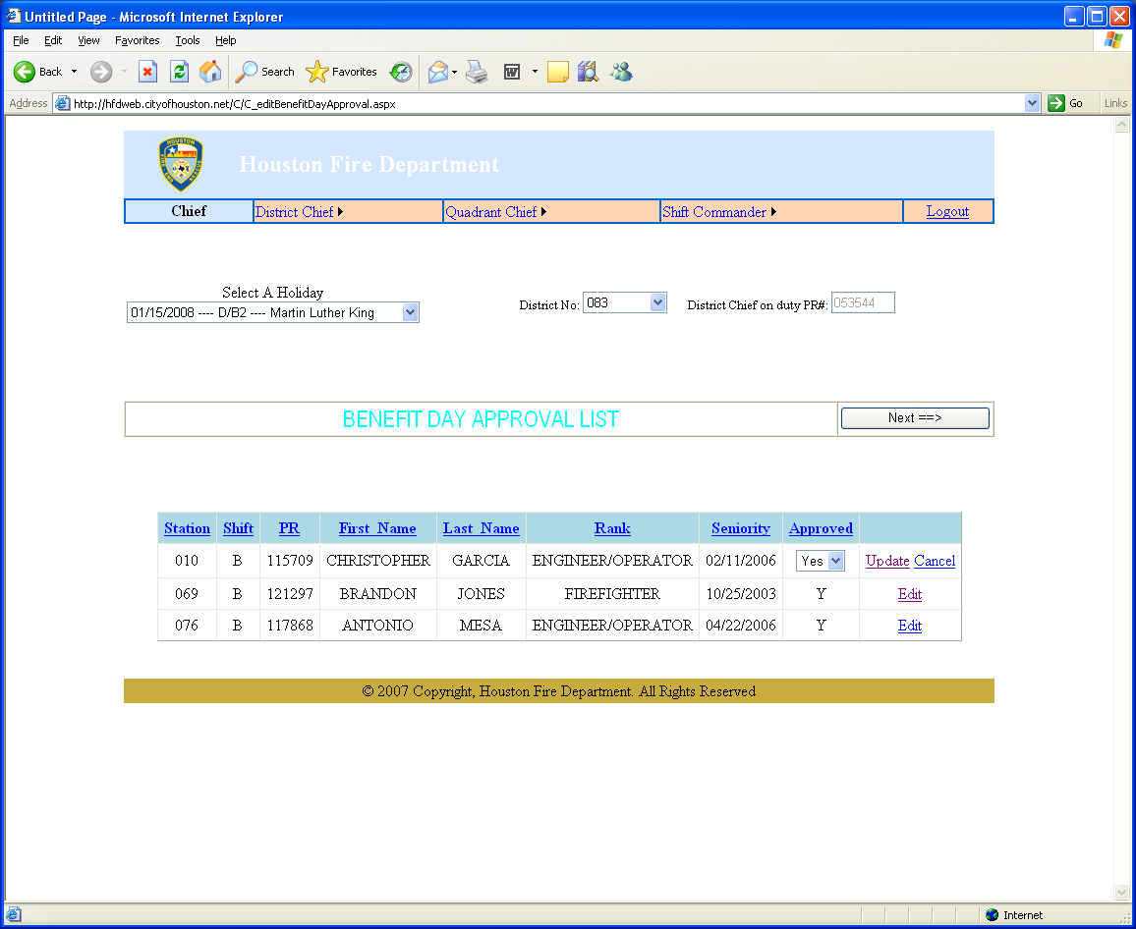

The Chief can approve or disapprove and must click UPDATE to update the records.
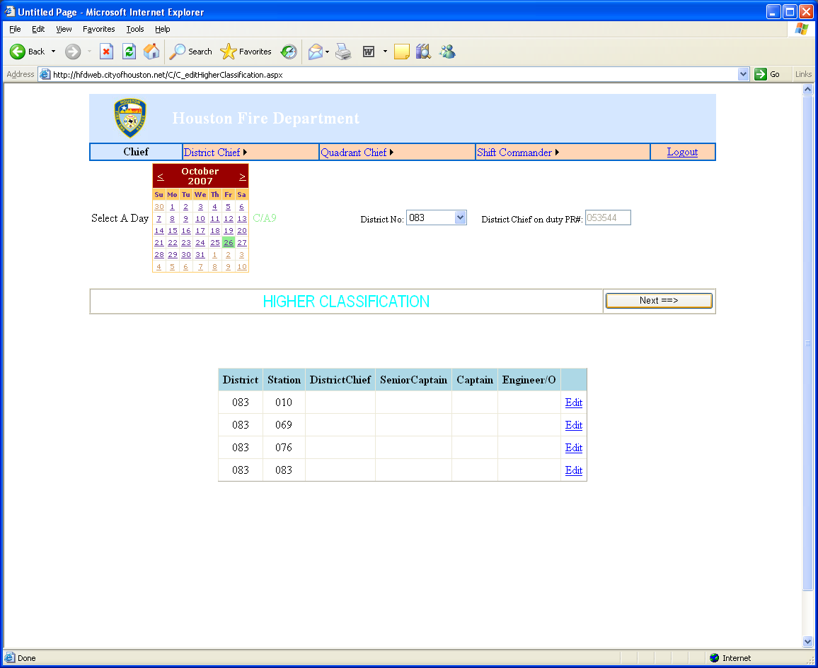

The Chief can view the number of Higher Classification staff on duty at each station in the district from this webpage.

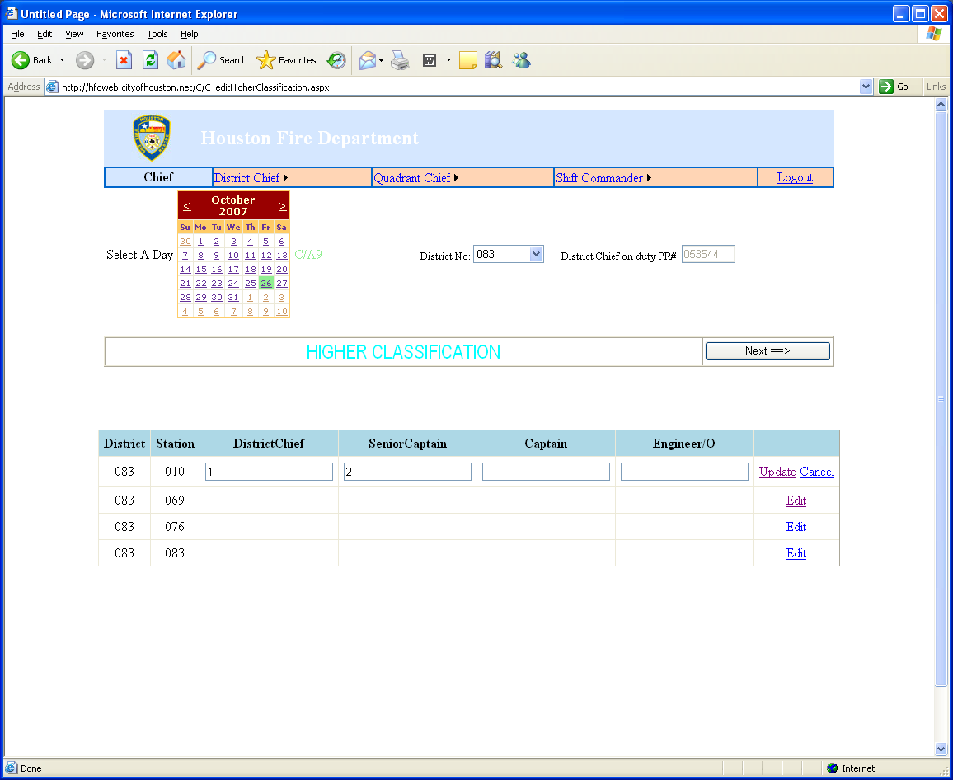

The Chief can edit the number of staff at each station in the district.

UPDATE must be clicked to update the records.

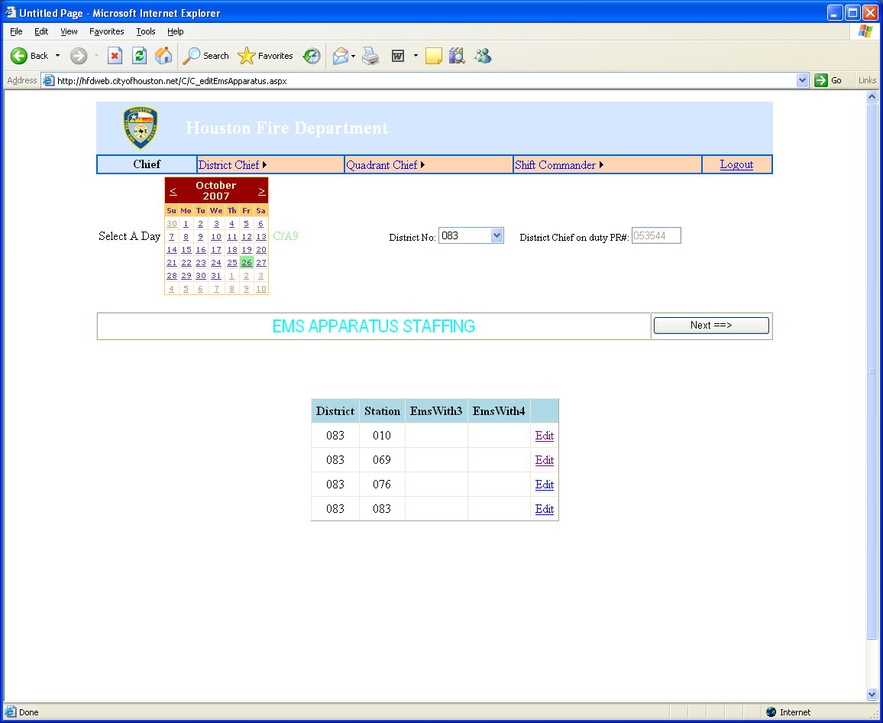

The Chief can view and edit the number of EMS apparatus staffing.

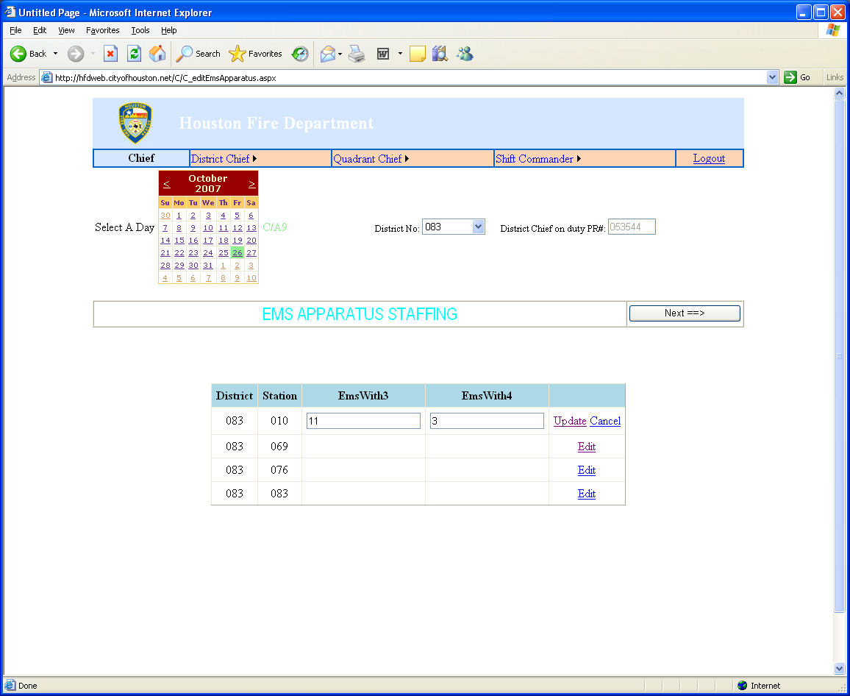

The chief can update the number of EMS in each category and must click UPDATE to update the records.

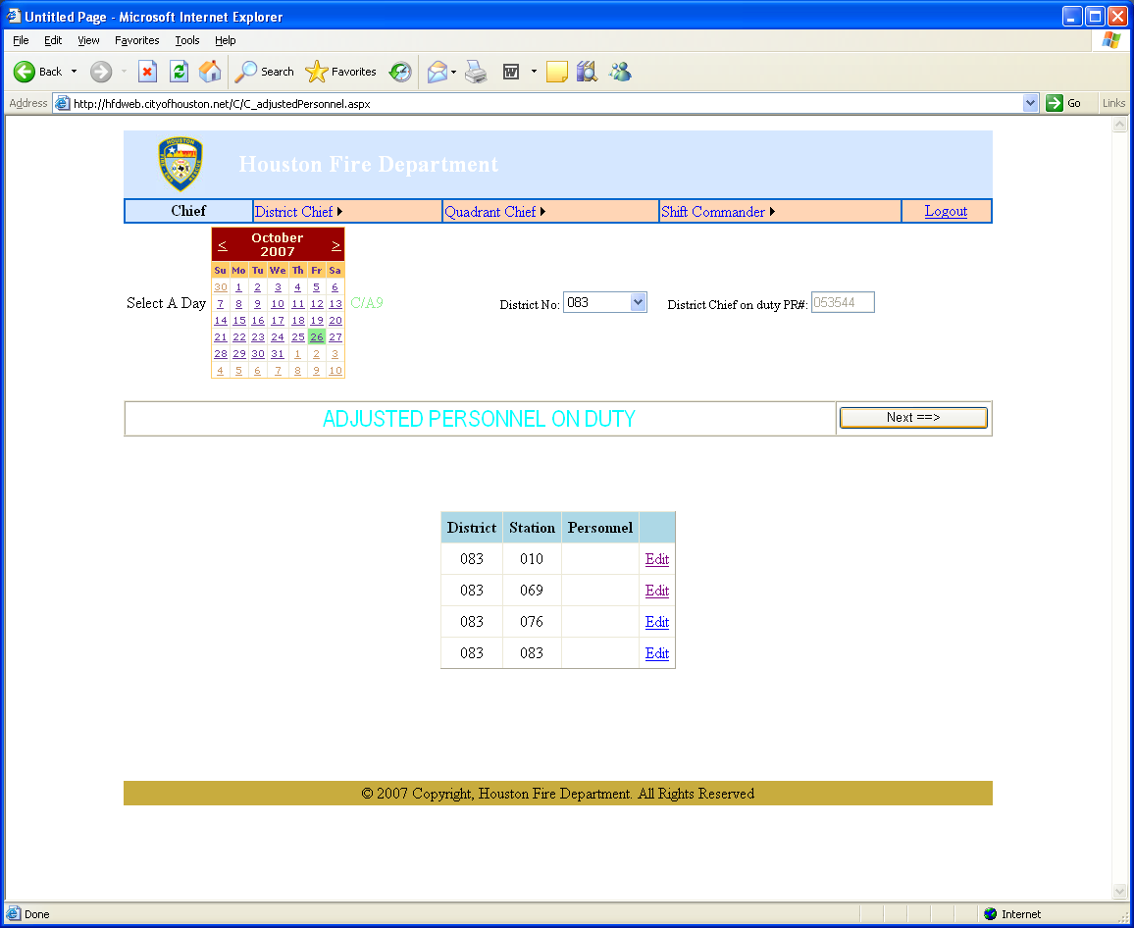

The Chief can view and edit the number of personnel on duty.

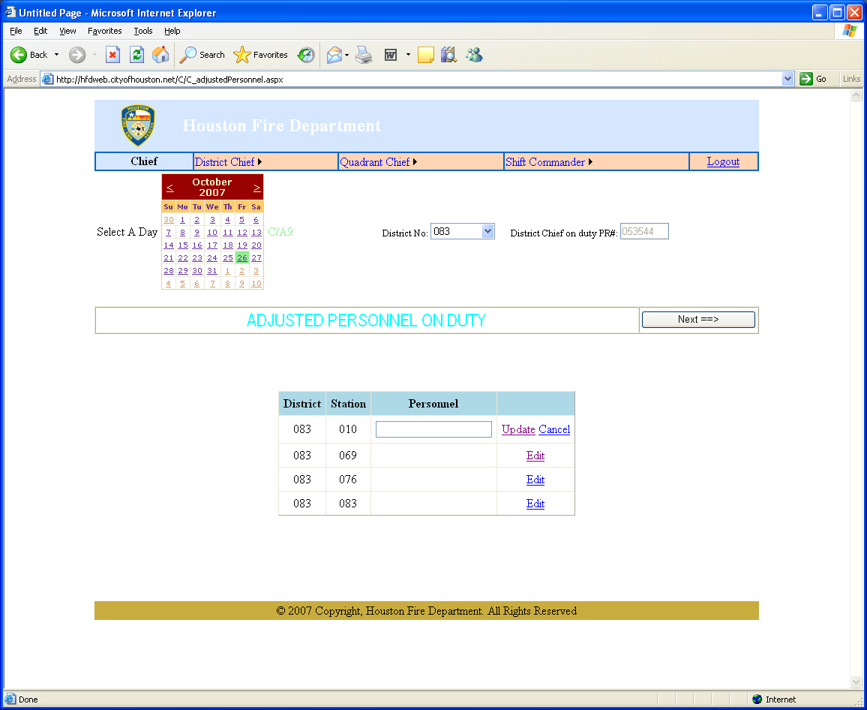

The Chief can edit the number of personnel on duty up to 9. He must click UPDATE to update the records.

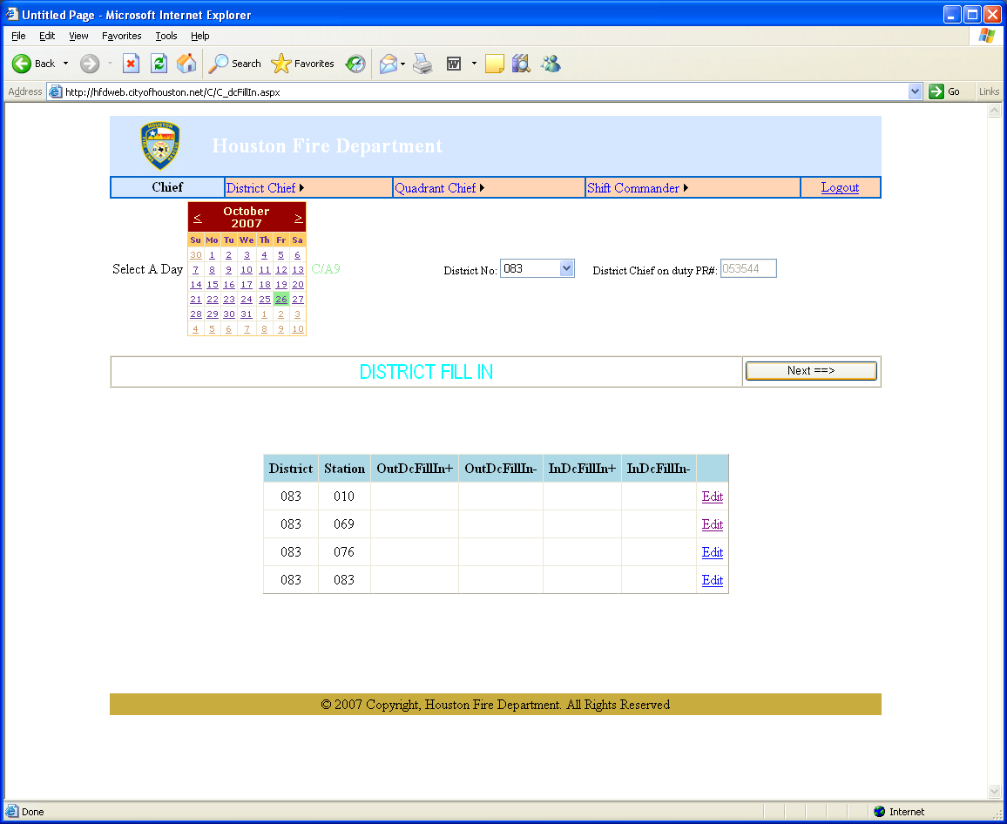

The Chief can view and edit the District Fill In.

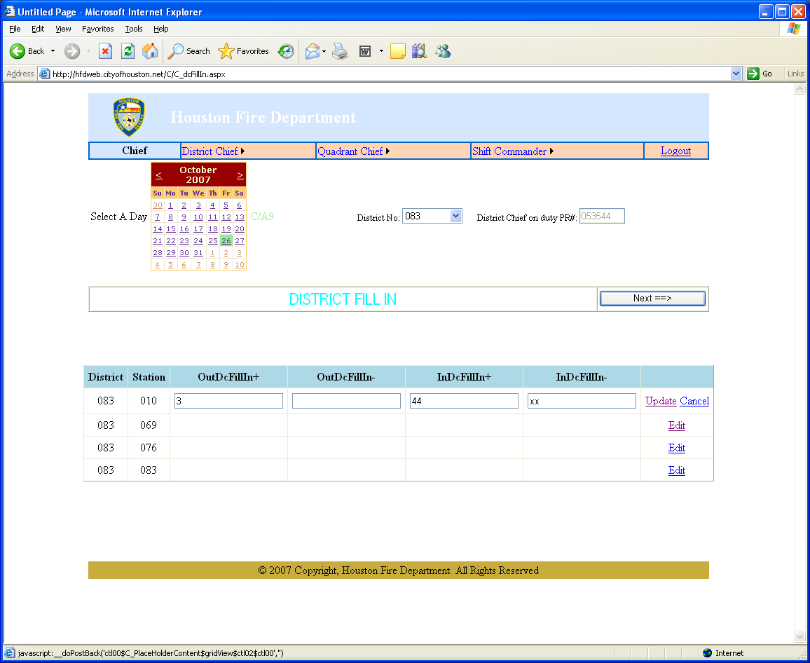

The Chief can edit the number of fill ins. He must click UPDATE to update.

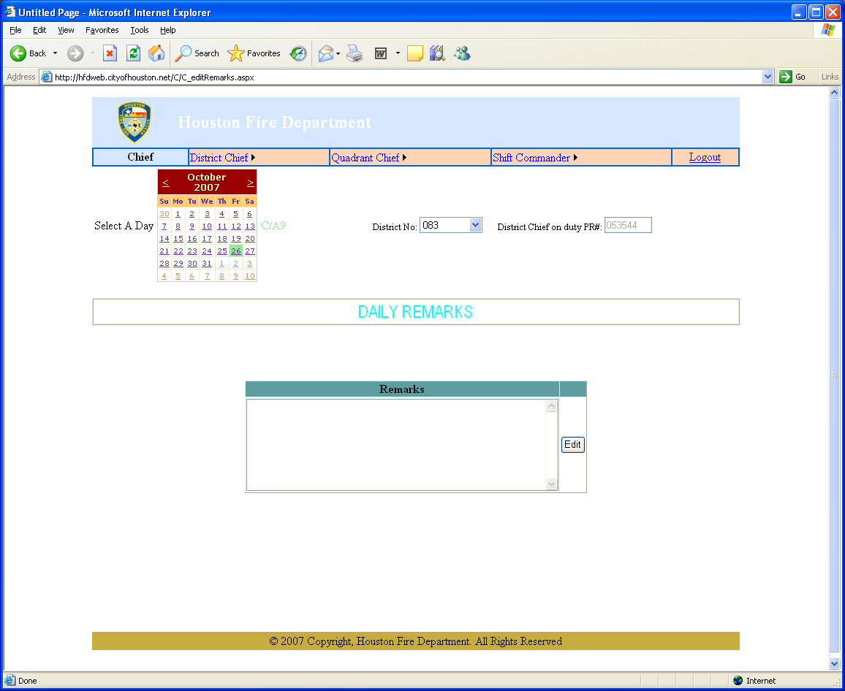

The Chief can make his daily remarks here. He must click EDIT to make or update any remarks.

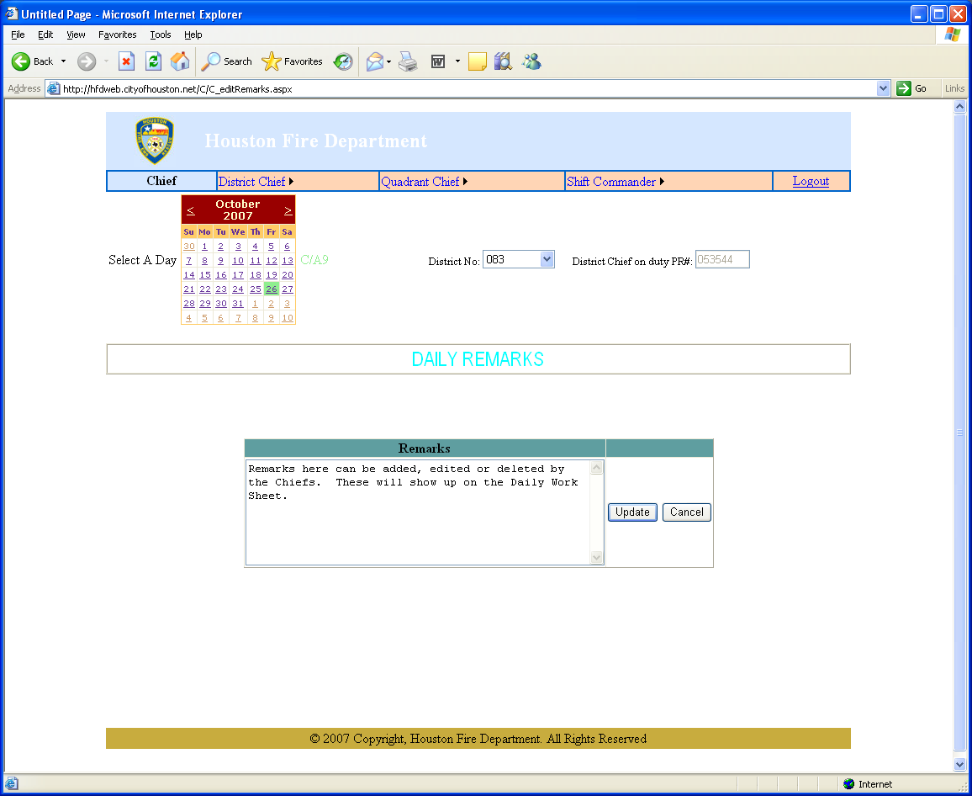

The Chief can add, edit or delete here. He must click UPDATE to update the records.

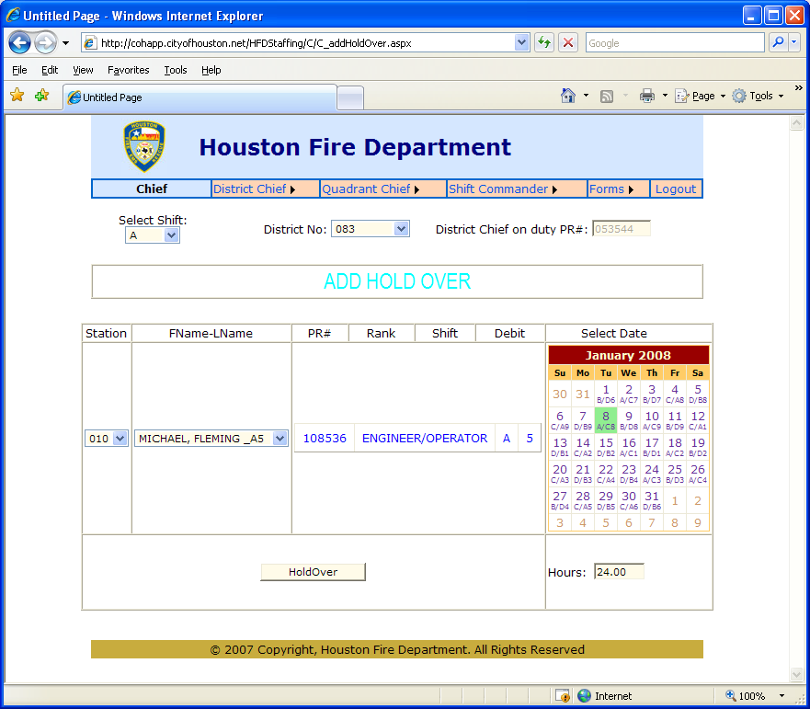
1
2
3
4
5
6
7
The Chief can add Hold Over on this site by selecting
the Shift
the District
the Station
the Name
the date
the number of hours.
Then click HoldOver.
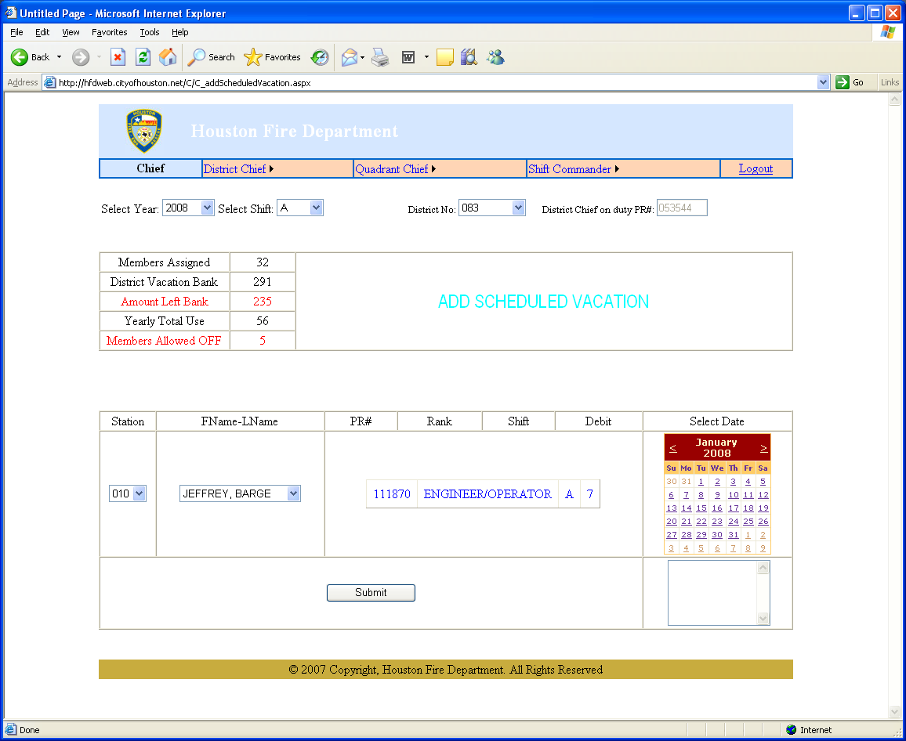

The Chief can add scheduled vacation time on this webpage.
He selects the Year
the Shift
the District
the Station
the Member
the Date.

He must click SUBMIT to update the records.

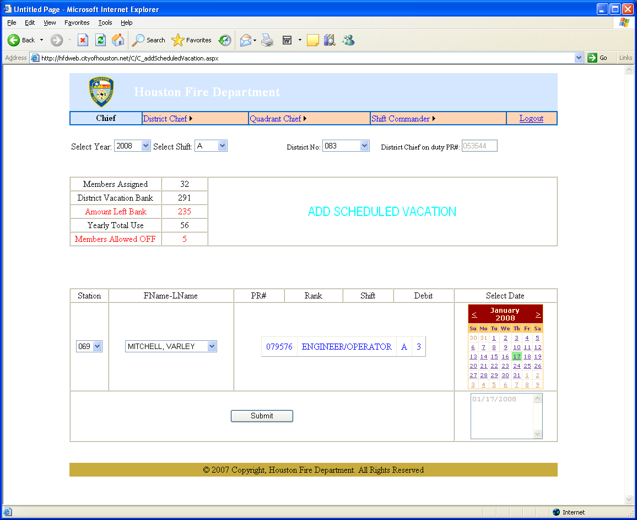

The small box in the lower right-hand corner will indicate the dates that have been selected for vacation.

Click SUBMIT to update the records.
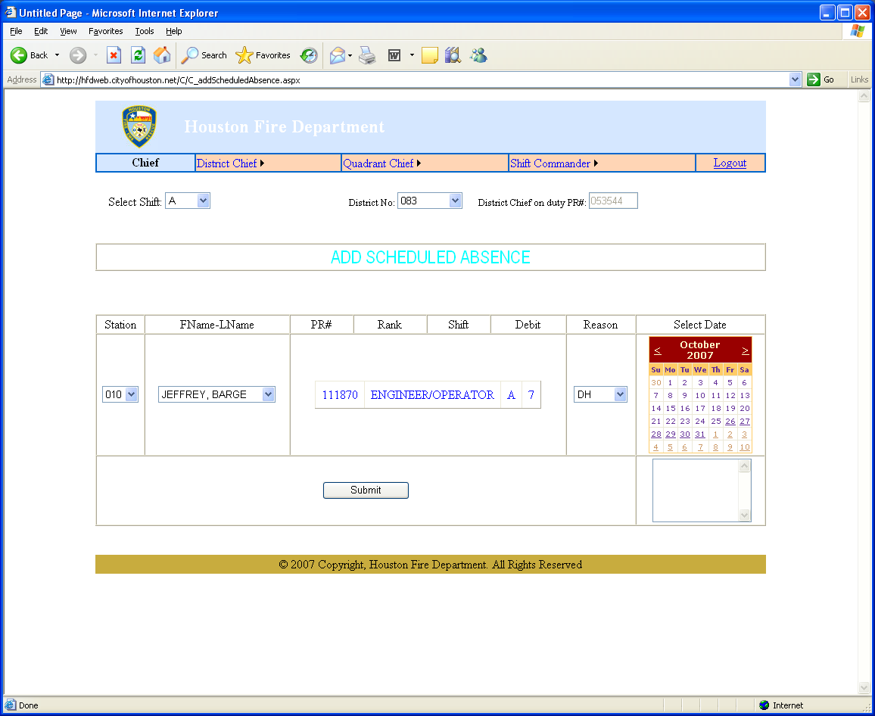

The Chief can update the records from this page to schedule non-vacation leave.
He can select the Shift
the District
the Station
the Member
the Reason Code (Reason Codes are generated by SAP.)
the date.

The date will appear in the lower right-hand memo box.
He must click SUBMIT to update the records.
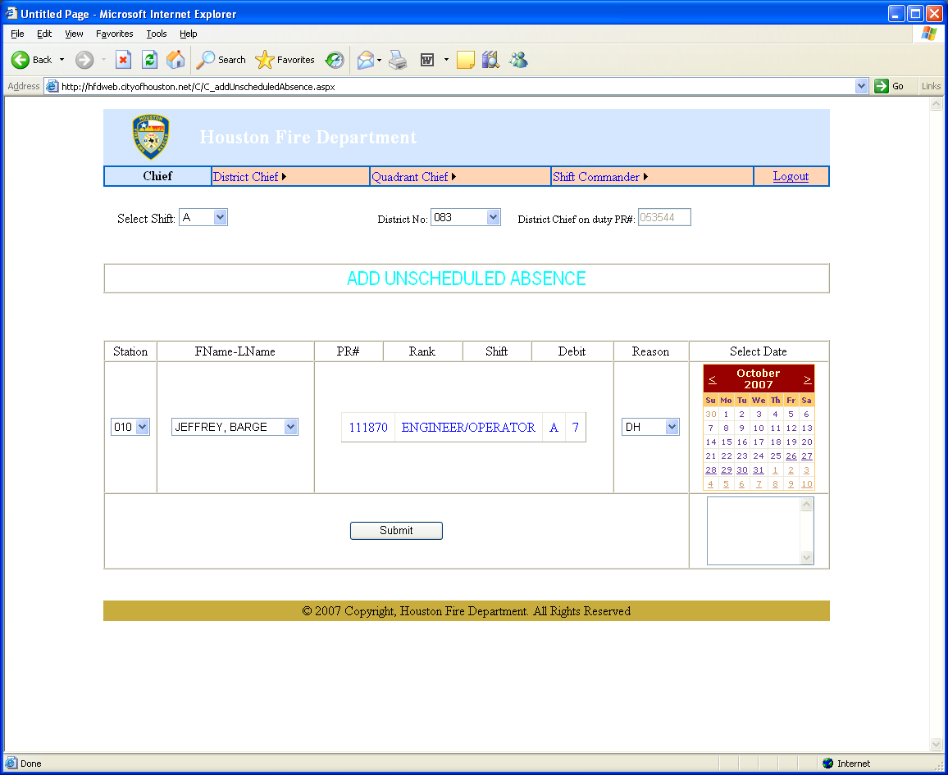

The Chief can update unscheduled absences on this webpage. He can select the shift, district, station, member, reason code and date. (Reason Codes are generated by SAP.)

He must click SUBMIT to update the records.

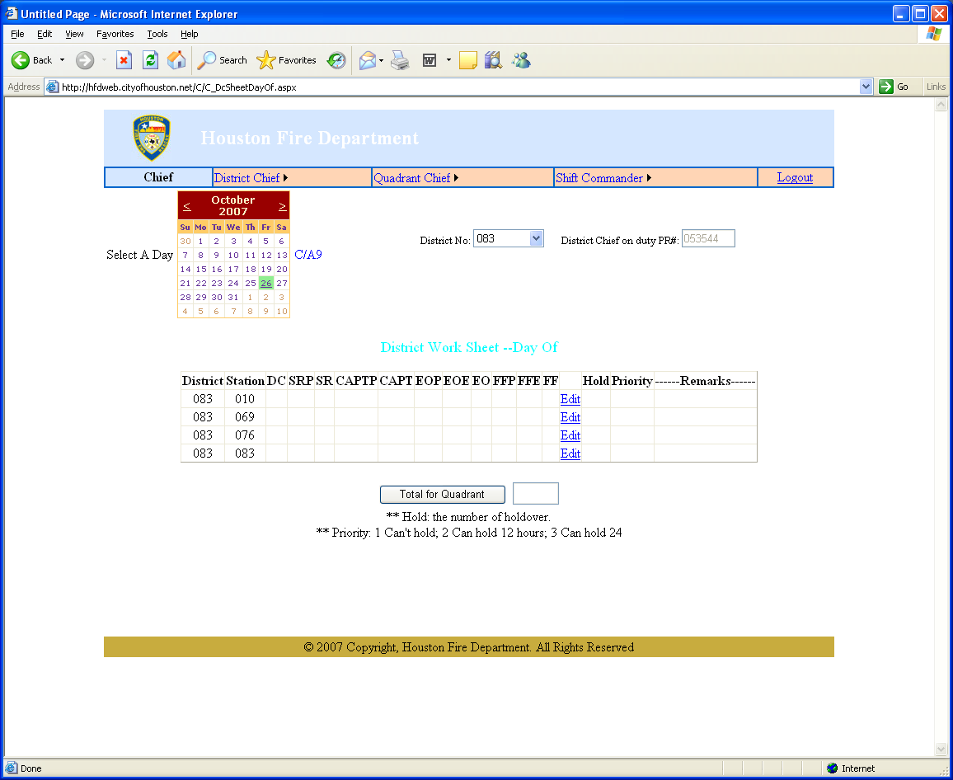

The Chief can view and edit staffing totals on this webpage.

He can select the day and district.

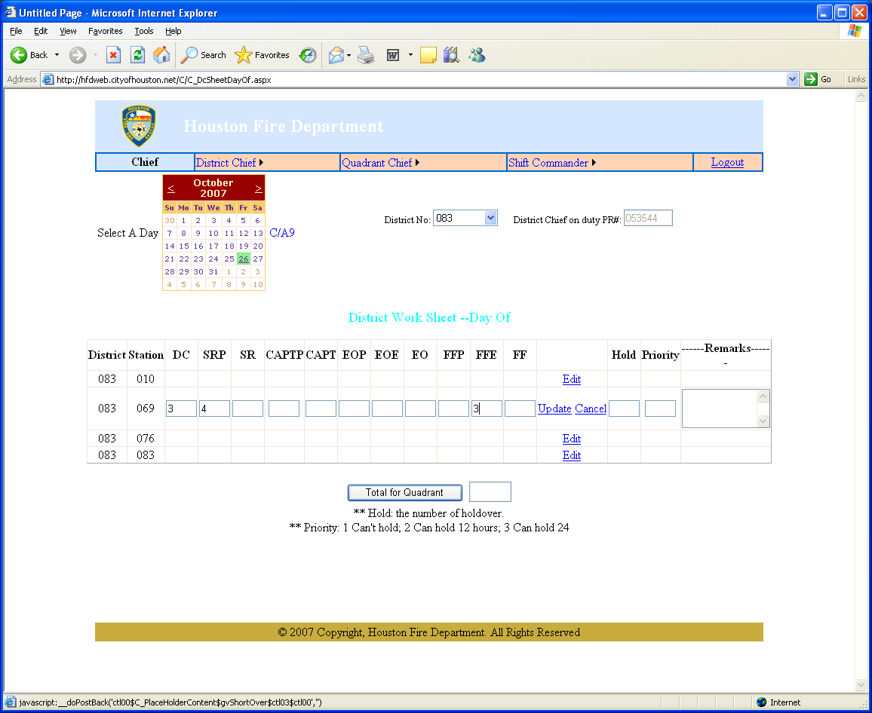

The Chief can enter the numbers in the required boxes and click UPDATE to update the record.

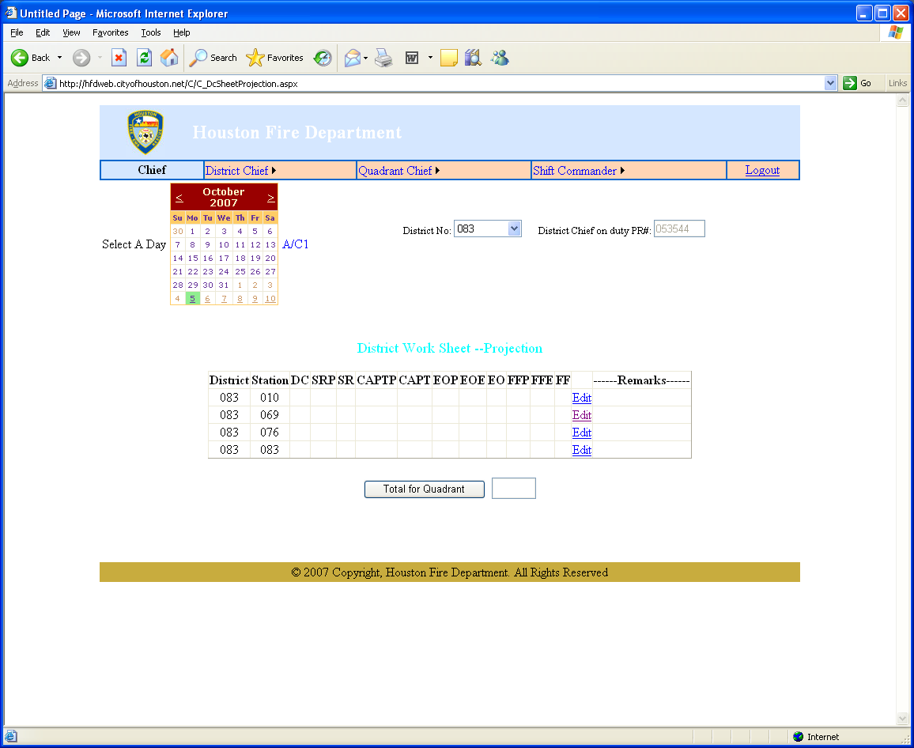

The Chief can view and edit the District Work Sheet Project from this webpage. He can select the day and the district.
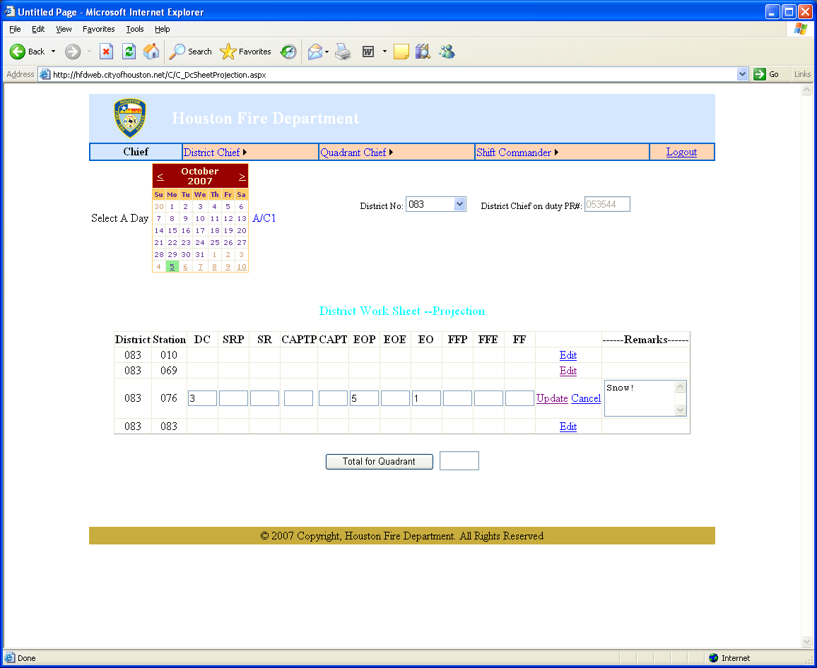

The Chief can edit the number in each box along with a remark for each row. He must click UPDATE to update the records. Chief can edit the number in each box along with a remark for each row. He must click UPDATE to update the records.

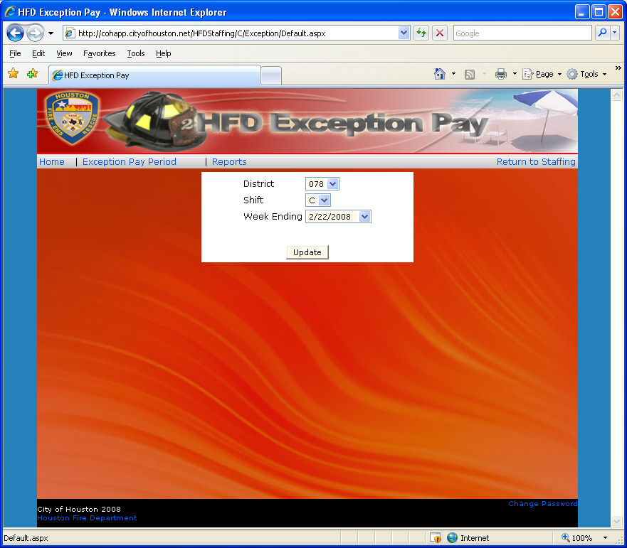

The Chief can update Exception Pay from this site.
He selects the District
the Shift
the Week Ending dates and clicks UPDATE.

Then when he clicks Exception Pay Period, he will get the Roster List.
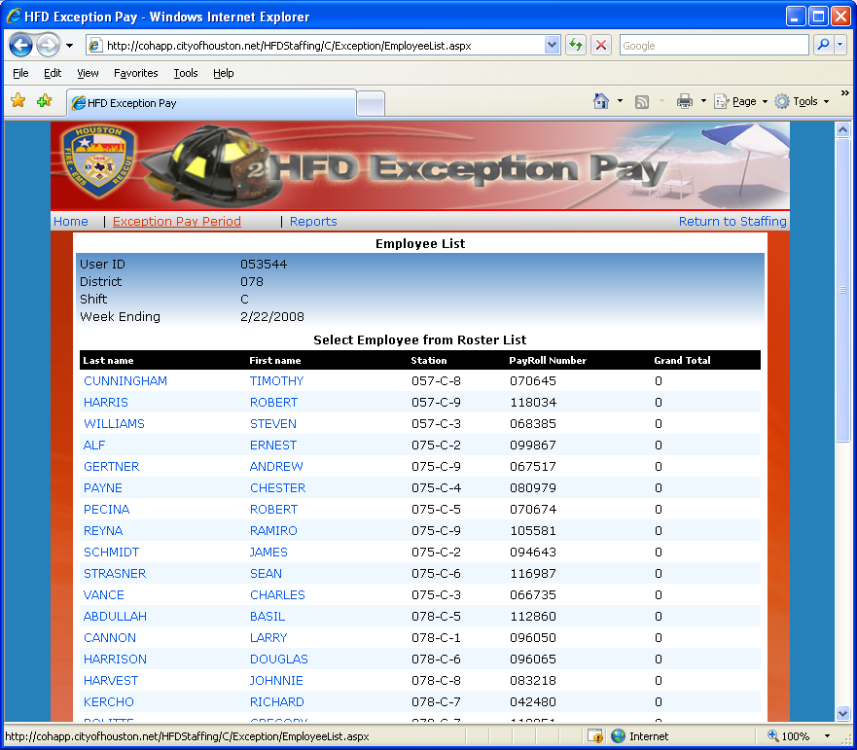

From this site, the chief can select an employee.
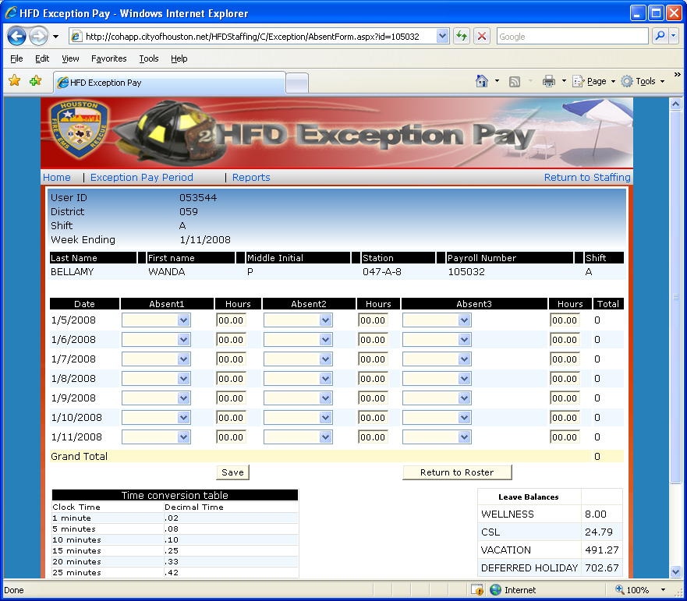

The chief can update the Absent Codes and the Hours from this site.
He can Return to Roster and continue his updates.

For Manual Purposes, not all data has been displayed.
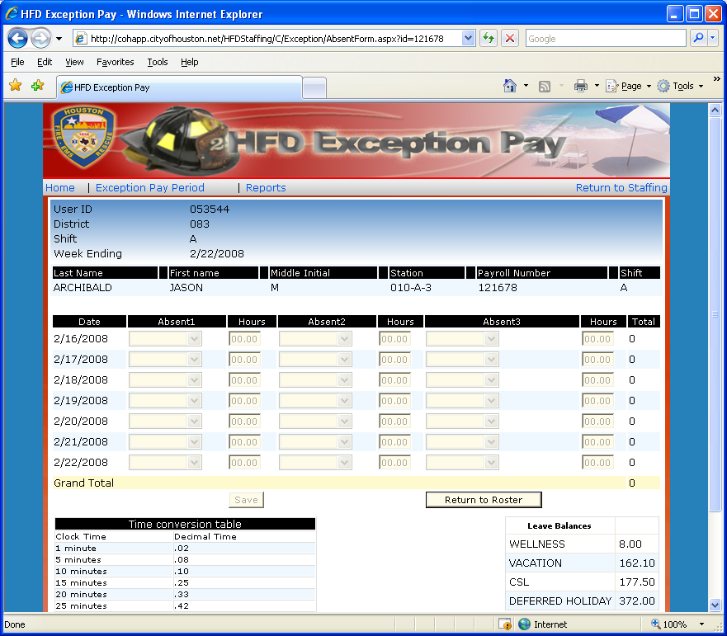

The selections will be greyed out if no updates are possible.

For Manual Purposes, not all data has been displayed.
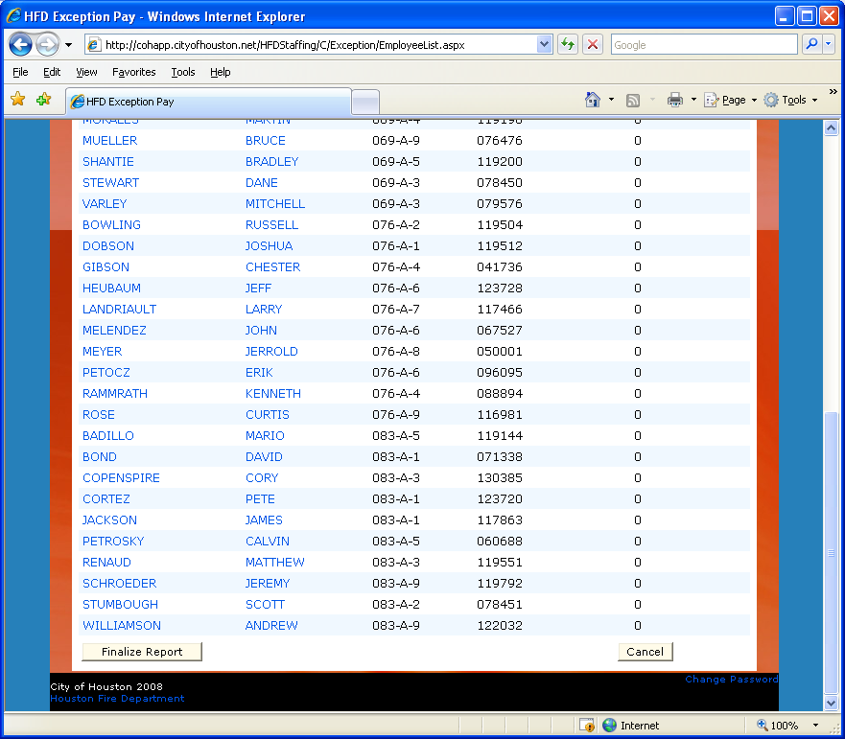

The Chief can Finalize the Report from the button at the bottom of the page
or he can cancel the changes.
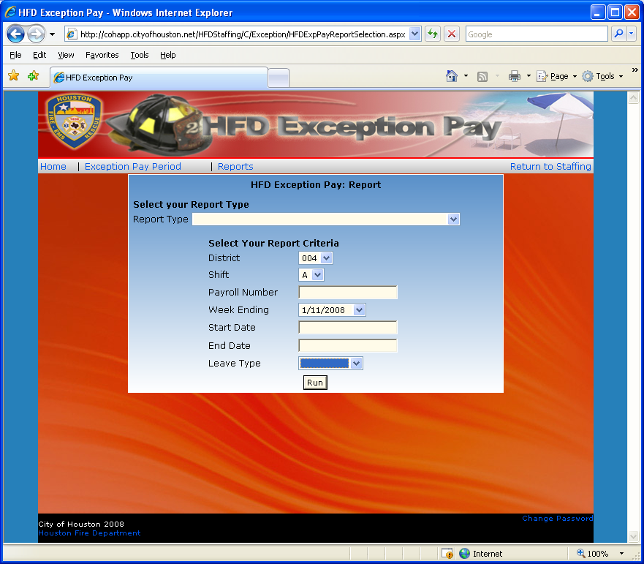

The Chief can run reports from this site by selecting the various criteria and clicking RUN.
He will have the option to open the report in ADOBE or to save it.

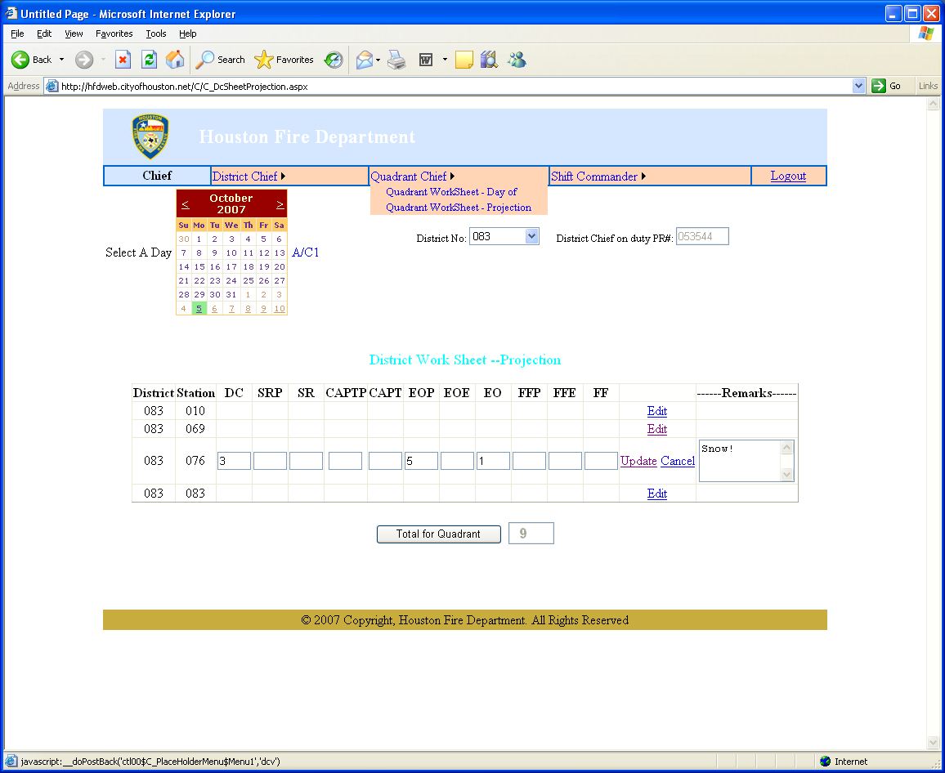

The Quadrant Chief can point his mouse at the Quadrant Chief box for a drop-down box to select Quadrant Worksheets.

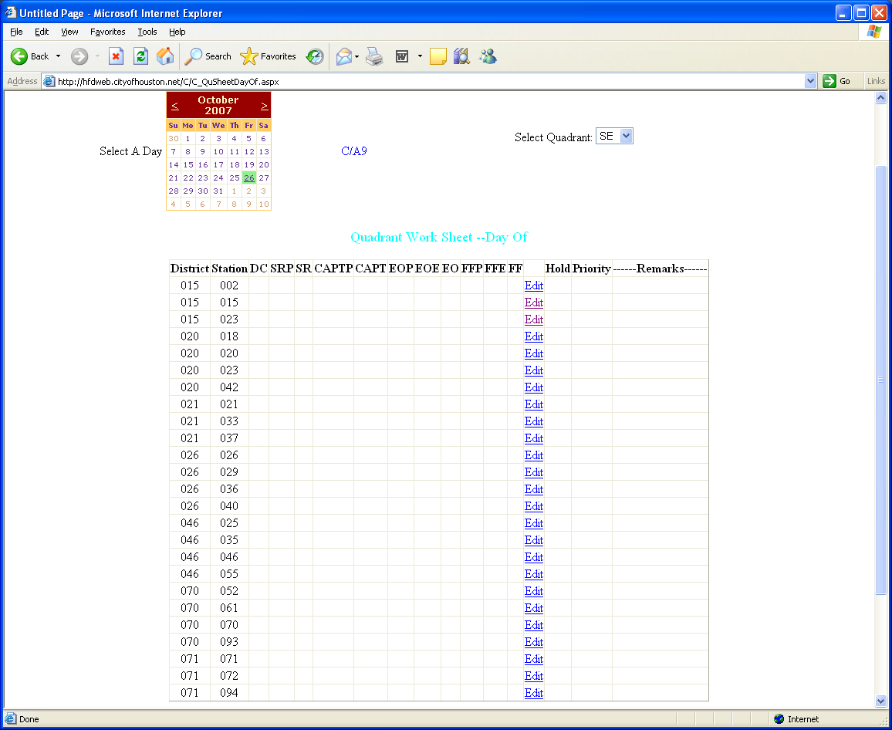

The Quadrant Chief can view and edit from this webpage. He can select the quadrant and then the EDIT button to change station numbers.

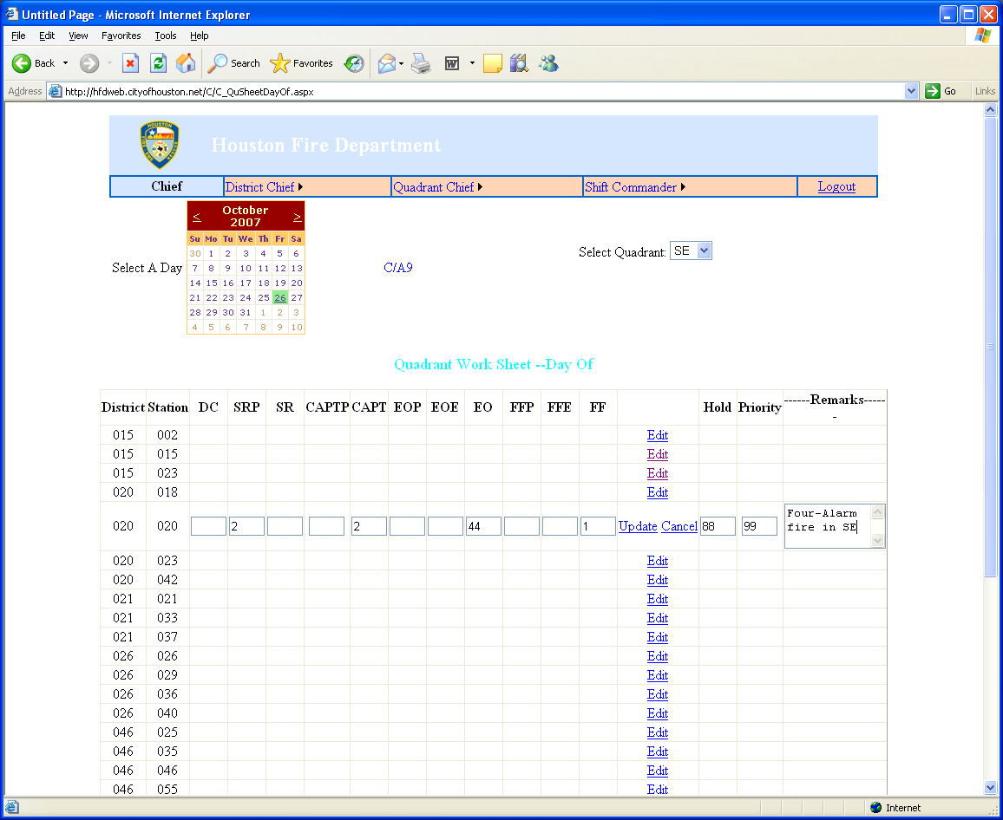

The Quadrant Chief can update the numbers in the selected boxes and add remarks. He must click UPDATE to update the record.

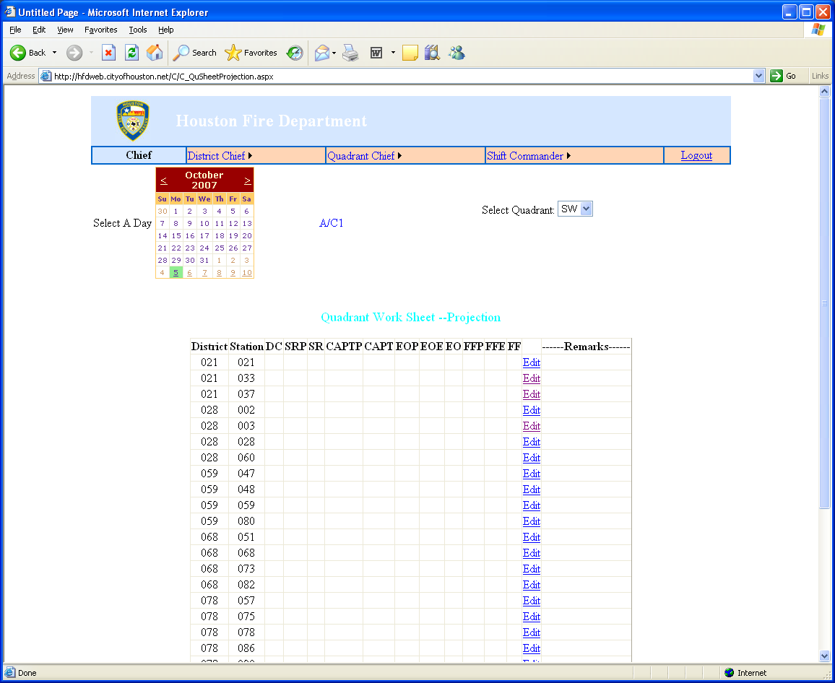

The Quadrant Chief can select an underlined date and quadrant and then click EDIT for the station he needs to update.

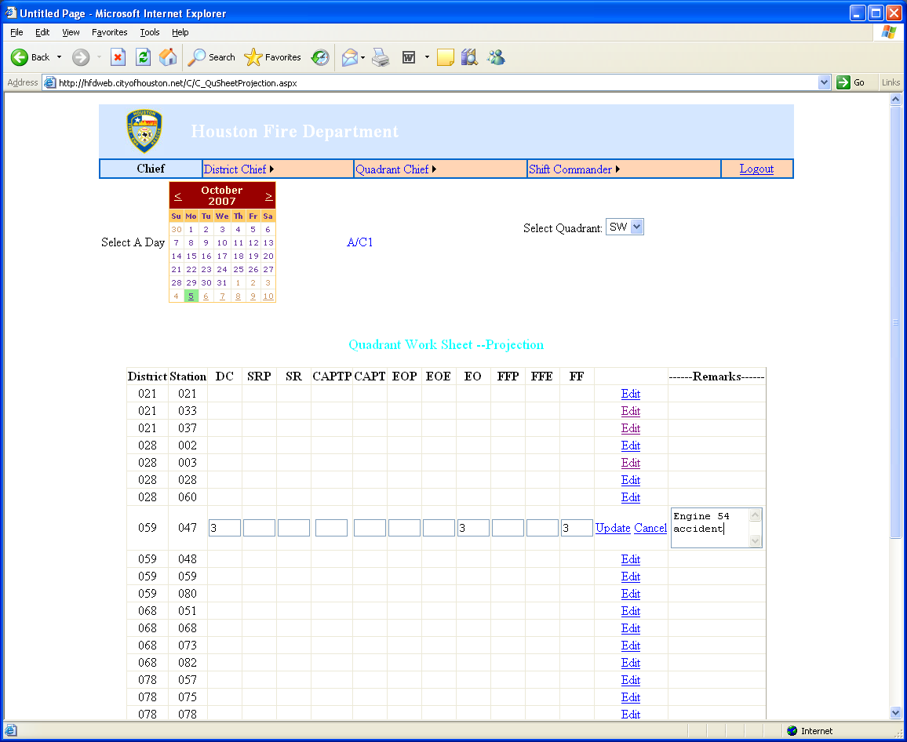

The Quadrant Chief can update the numbers and make remarks. He must click UPDATE to update the record.

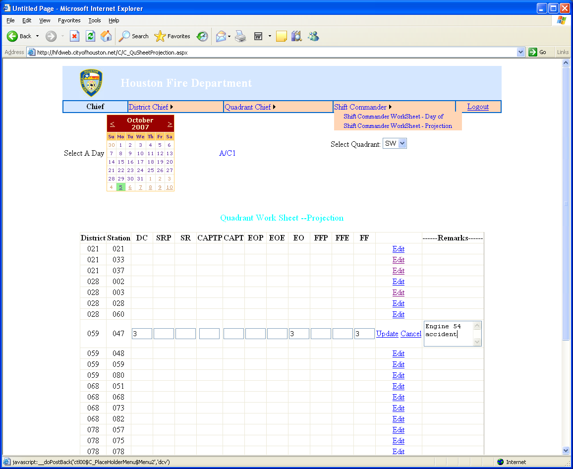

The Shift Commander can select the worksheet he requires by placing his mouse over the Shift Commander box for a drop-down menu.
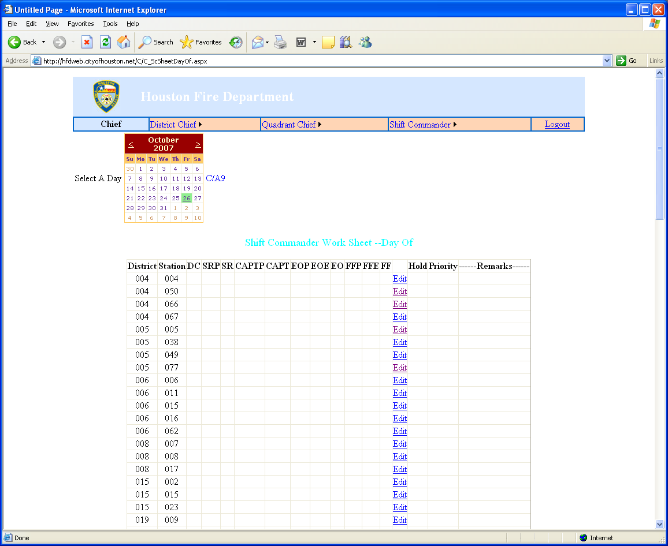

The Shift Commander clicks EDIT for the station he needs to update.

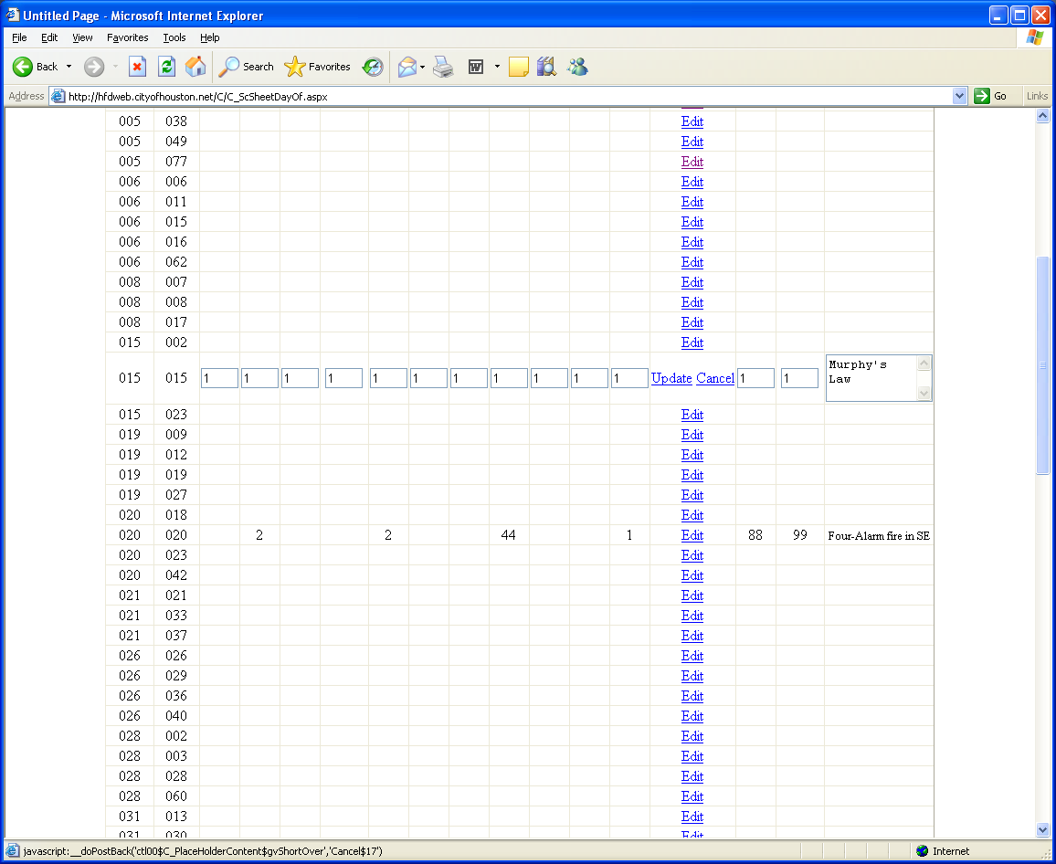

The Shift Commander can update the number in the appropriate boxes and add remarks. He must click UPDATE to update the record.

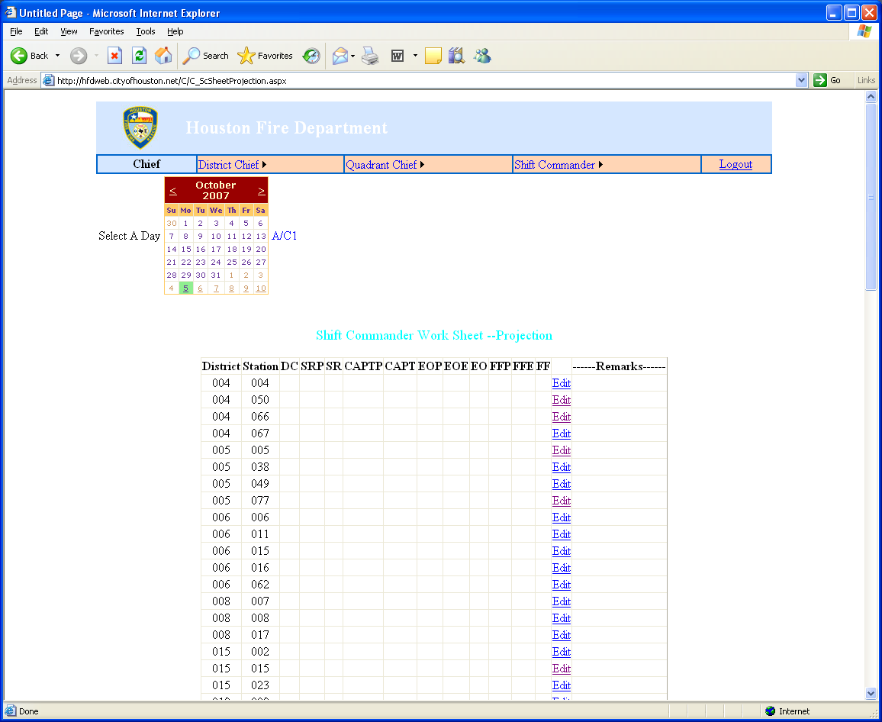

The Shift Commander can select a day from the calendar for his projection. He can only select underlined days. He clicks Edit it the appropriate row for the station.

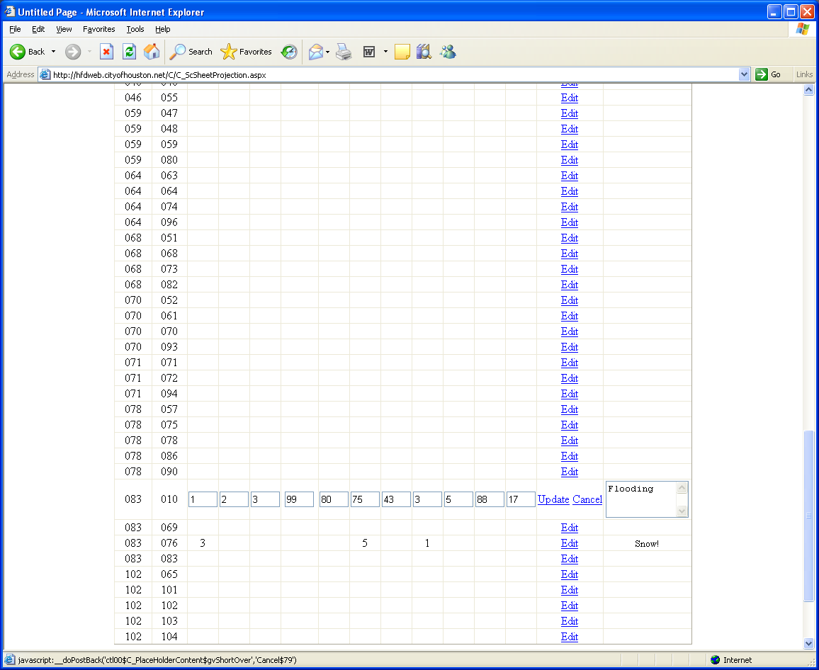

The Shift Commander can enter the numbers into the boxes of the station he needs to update along with remarks in the remarks column. He must click UPDATE to update the record.

SAP Absence Code Definitions

SAP Leave Type | Description
ABLP | Assoc. Business Leave Poo
AWOL | AW = Accrues but no pay
CBSP | City Business -Phase Down
CBUS | City Business
CMPS | Comp Time - Scheduled
CMPS | Comp Time
CMPU | Comp Time - Unsched.
CMXS | Exempt Comp. Time-Sched.
CMXU | Exempt Comp. Time-Unsch.
CSBL | CSL Sick Plan
CTFS | Frozen Comp. Time - Sched
DFAM | Family Death
DHOL | Deferred Holiday
DMLD | Decision Making Leave Day
DPTO | Donated Sick
DSCK | Donated Sick
FHOL | Vacation-Unscheduled
FHOL | Floating Holiday
FMDS | FMLA - Donated Sick
FMLP | FMLA - Classified
FMLS | FMLA - Sick
FMLU | FMLA - No Pay
FMLV | FMLA - Vacation
FMPL | Personal Days
FURL | Furlough
IACT | IA - stops accrual
IDND | Indemnity Pmt Reduction
IDOK | Injury Dock
ILEV | Injury Leave
JURY | Jury Duty
LTDP | Leave Trans Duty Pay
LTDV | Leave Trans Duty Vac
LVDR | Leave Trans Doctor
LVTS | Leave Total Sick
LVTV | Leave Total Vacation
LWOP | Leave without pay
MILT | Military Leave
NLFB | No value leave frz.
PBLV | Pension Business Leave
PDWN | Training
PDWN | Vacation-Scheduled
PDWN | Phase Down
PERS | Personal Days
PFTS | PFT-Scheduled
PFTU | PFT-Unscheduled
PTOS | PTO-Scheduled
PTOU | PTO Unscheduled
RDWP | Relieved of Duty w/ Pay
SICK | PFT-Scheduled
SICK | PFT-Unscheduled
SICK | Vacation-Unscheduled
SICK | Sick Plan
SICK | PTO-Scheduled
SICK | PTO Unscheduled
TRNG | Training
UNBS | Union business
VACS | Vacation-Unscheduled
VACS | Training
VACS | PFT-Scheduled
VACS | PFT-Unscheduled
VACS | Vacation-Scheduled
VACU | Vacation-Unscheduled
VLWP | Vacation-LWOP
WELL | Wellness

Index

Absences | 16
Adding scheduled vacation time | 32
Adjusted Personnel on Duty | 25
Benefits Approval List | 19
Change password | 4
City Business Leave | 16
Daily Worksheet | 12
Death in the family | 16
Debit Day, edit | 14
Debit Day, view | 14
District Daily Remark | 29
District Fill In | 27
District WorkSheet – Day of | 36
District Worksheet – Projection | 38
E-mail update | 4
E-mail, add personal | 4
EMS Apparatus Staffing | 23
Exception Pay | 40
Fill In | 27
Finalize Exception Pay Report | 44
Forgotten password | 3
Guaranteed Holiday, apply | 10
Guaranteed Holiday, delete | 11
Guaranteed Holiday, view | 11, 18
Higher Classification | 21
Hold Over | 31
Jury Duty | 16
Leave, AWOL | 17
Leave, City Business | 16
Leave, Death in the family | 16
Leave, Jury Duty | 16
Leave, Military | 16
Leave, non-vacation | 16
Leave, non-vacation scheduling | 35
Leave, sick | 17
Leave, Training | 16
Leave, Vacation | 15
Log In | 2
Member Profile | 5
Menu Line | 4
Military Leave | 16
Overtime, assigned | 8
Overtime, history | 9
Overtime, request | 6
Password | 3
Password, forgotten | 3
Personnel on Duty, Adjusting | 25
Profile, member | 5
Quadrant Worksheet | 46
Quadrant Worksheet – Day of | 47
Quadrant Worksheet – Projection | 49
Reason Codes | 34
Scheduled Vacation, District | 15
Scheduling leave | 35
Scheduling, vacation | 32
Shift Commander Worksheet | 52
Shift Commander Worksheet – Day of | 52
Shift Commander Worksheet – Projection | 54
Training Leave | 16
Unscheduled absence, scheduling | 35
Unscheduled Leave, view | 17
Website Address | 1
Worksheet, Quadrant | 46

